**Lesson-12**

In order to make this lesson, we should load our data. For this lesson we work with SQL Server Database.

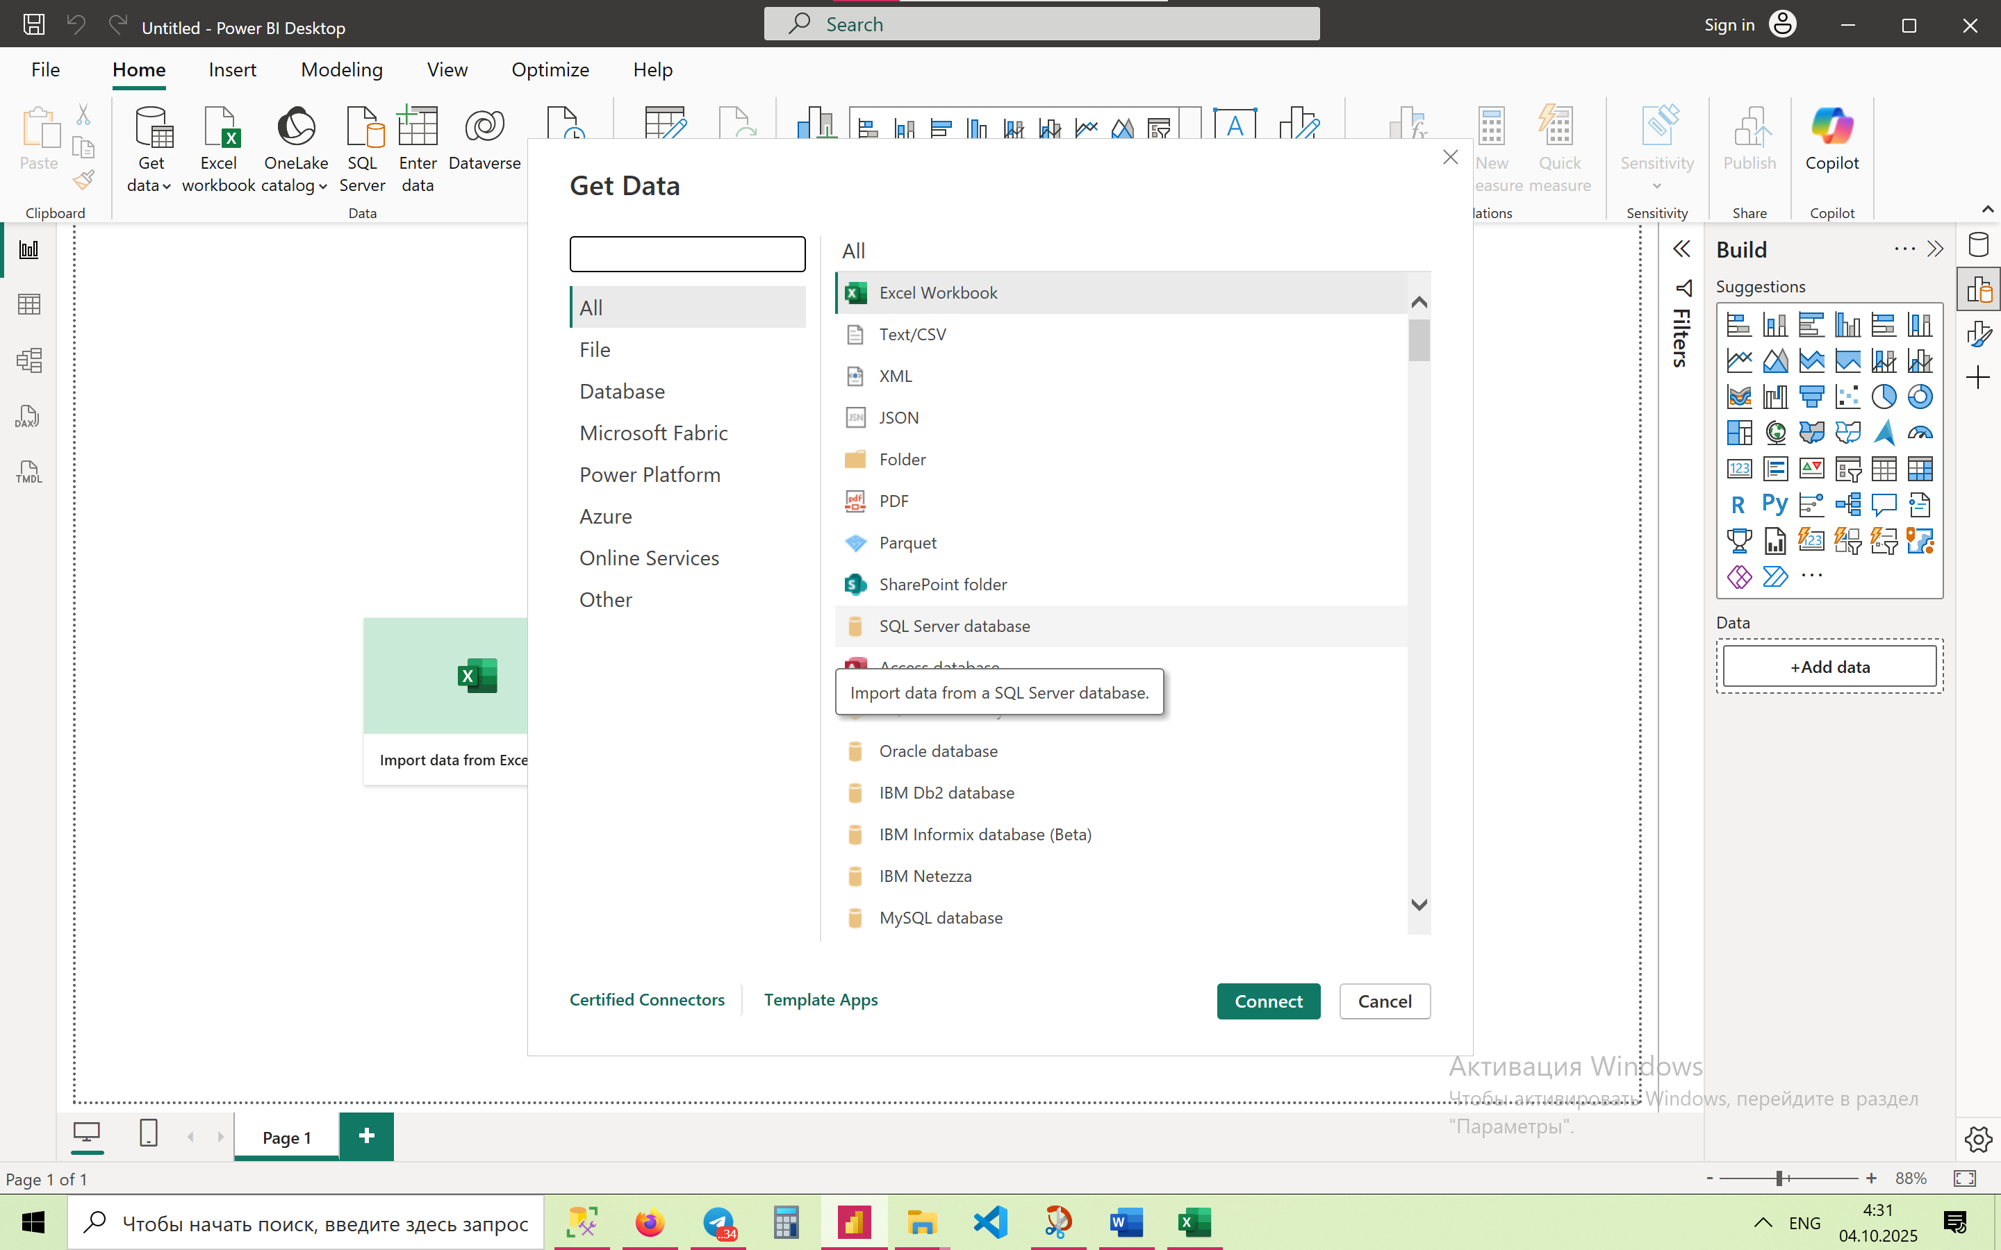

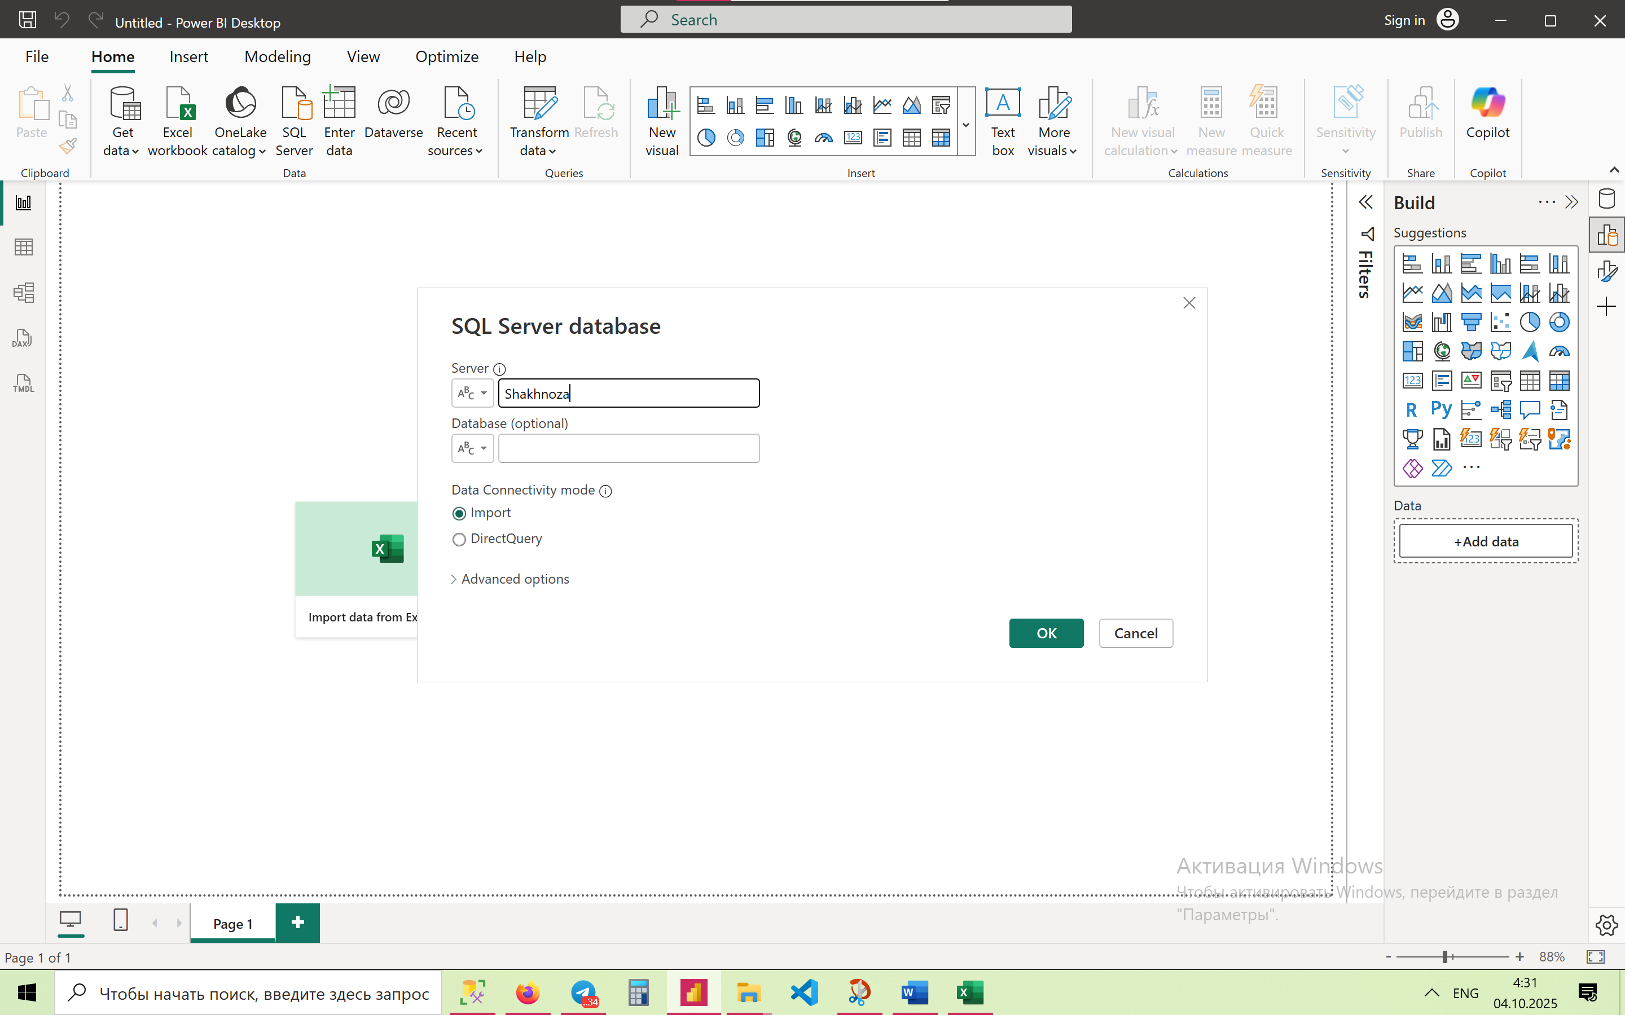

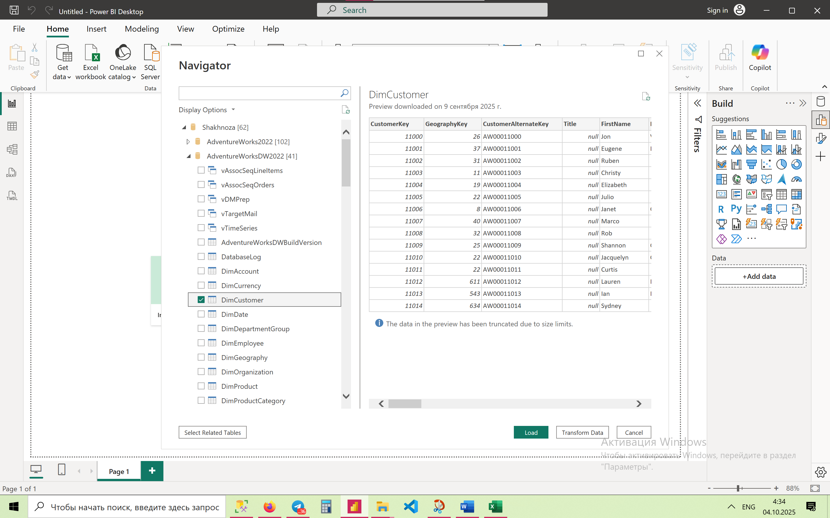

**🔹 Basic Level (1–10)**

1. **Concatenate First and Last Name**

FullName = DimCustomer[FirstName] & " " & DimCustomer[LastName]

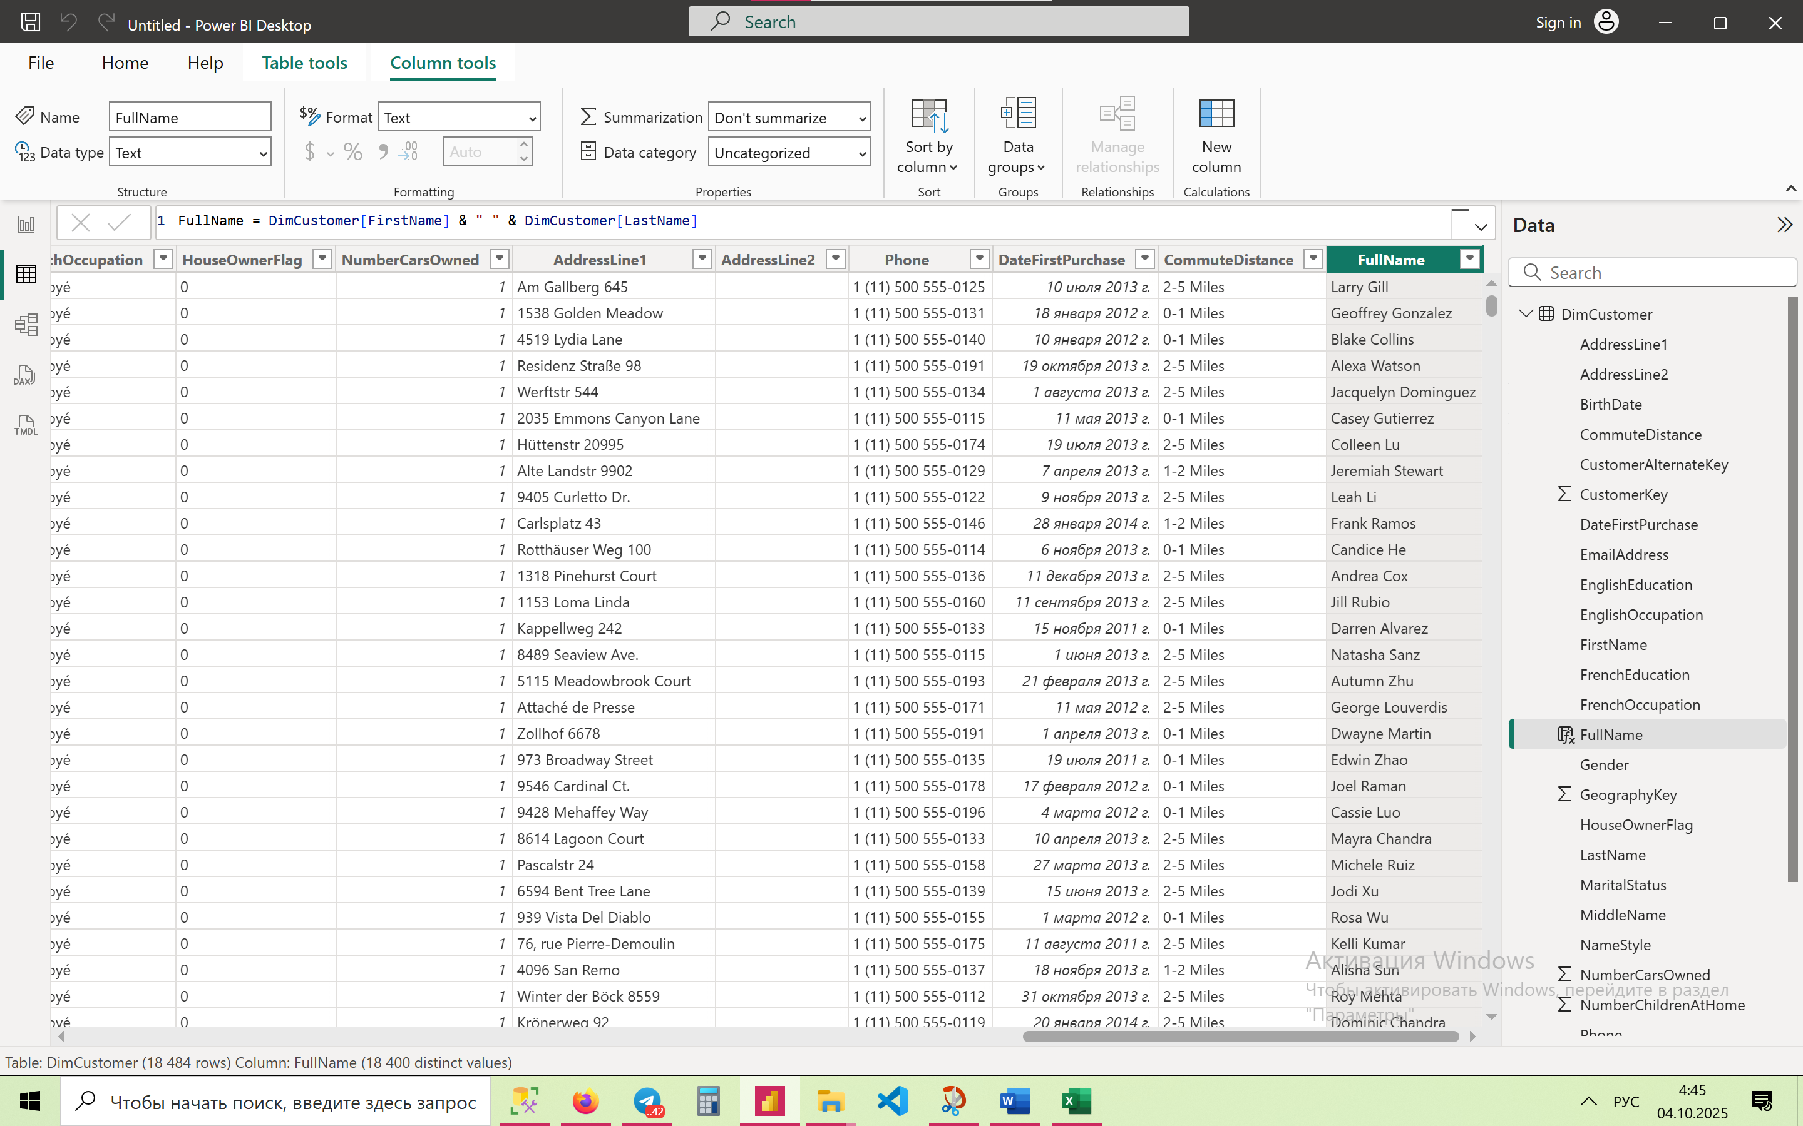

1. **Convert Email Address to Uppercase**

Email_Upper = UPPER(DimCustomer[EmailAddress])

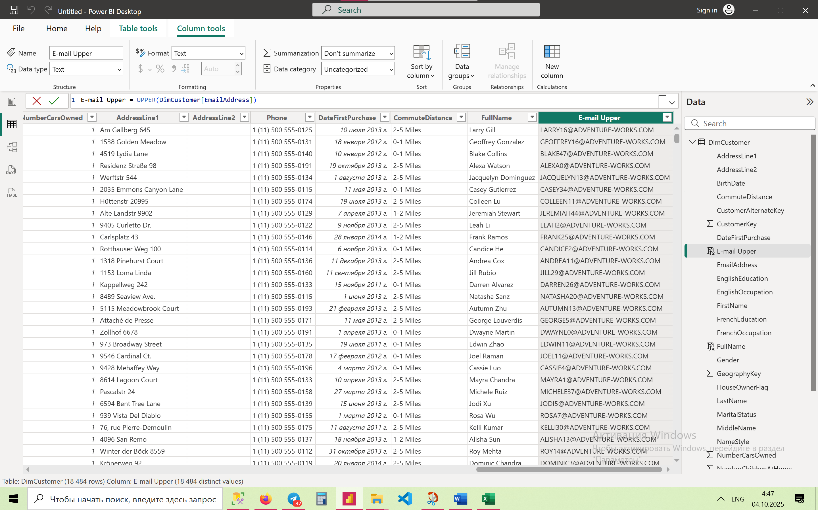

1. **Extract First 3 Characters from First Name**

First3Chars = LEFT(DimCustomer[FirstName], 3)

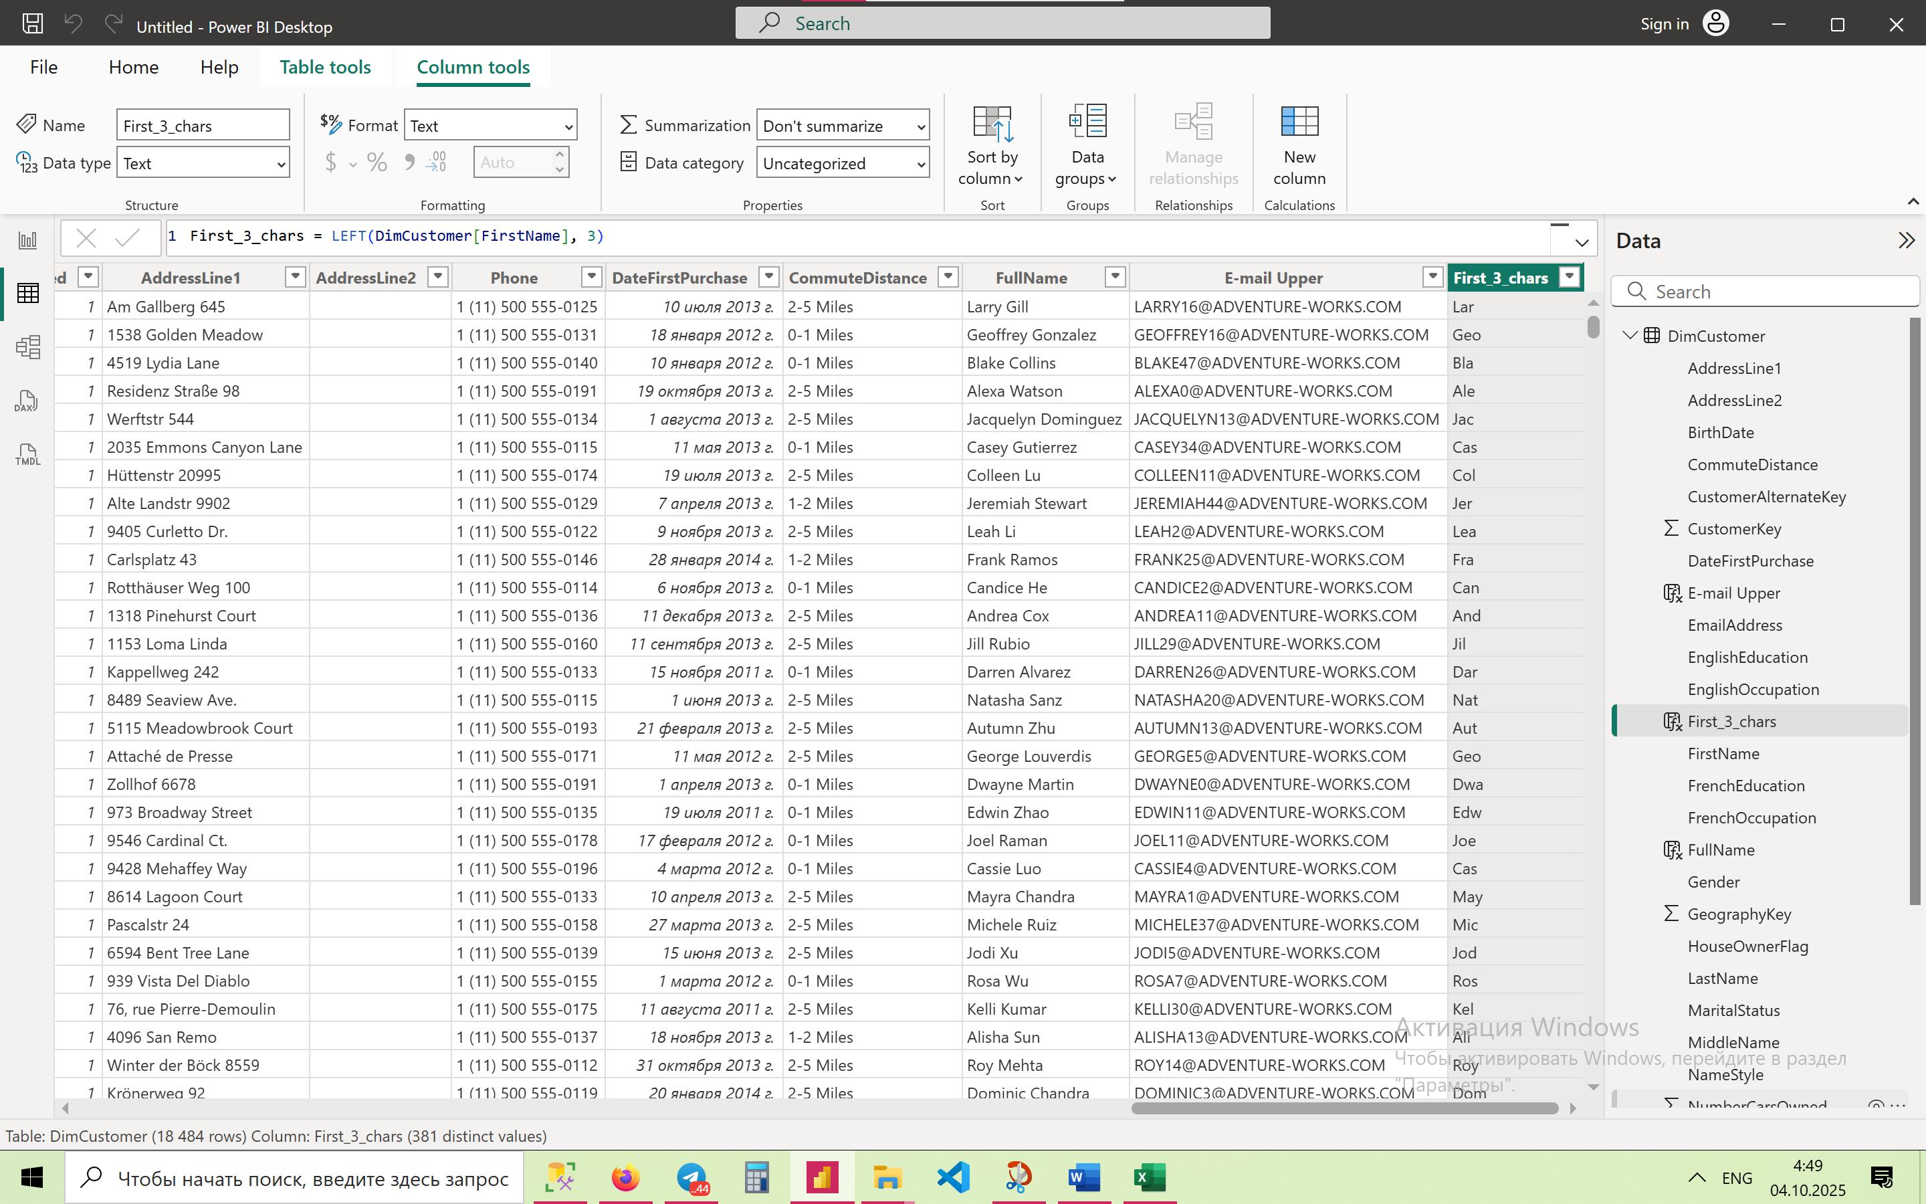

1. **Count Characters in Last Name**

LastNameLength = LEN(DimCustomer[LastName])

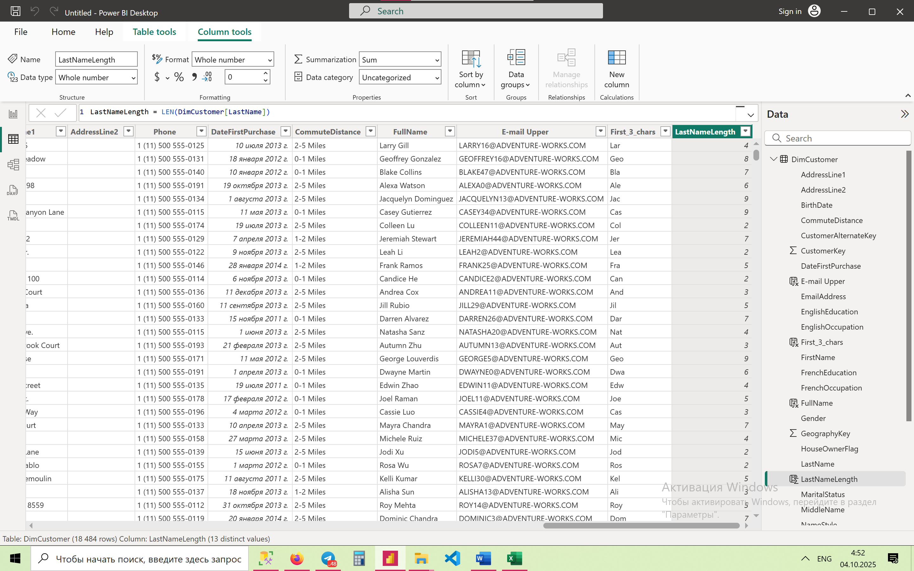

1. **Convert First Name to Lowercase**

FirstNameLower = LOWER(DimCustomer[FirstName])

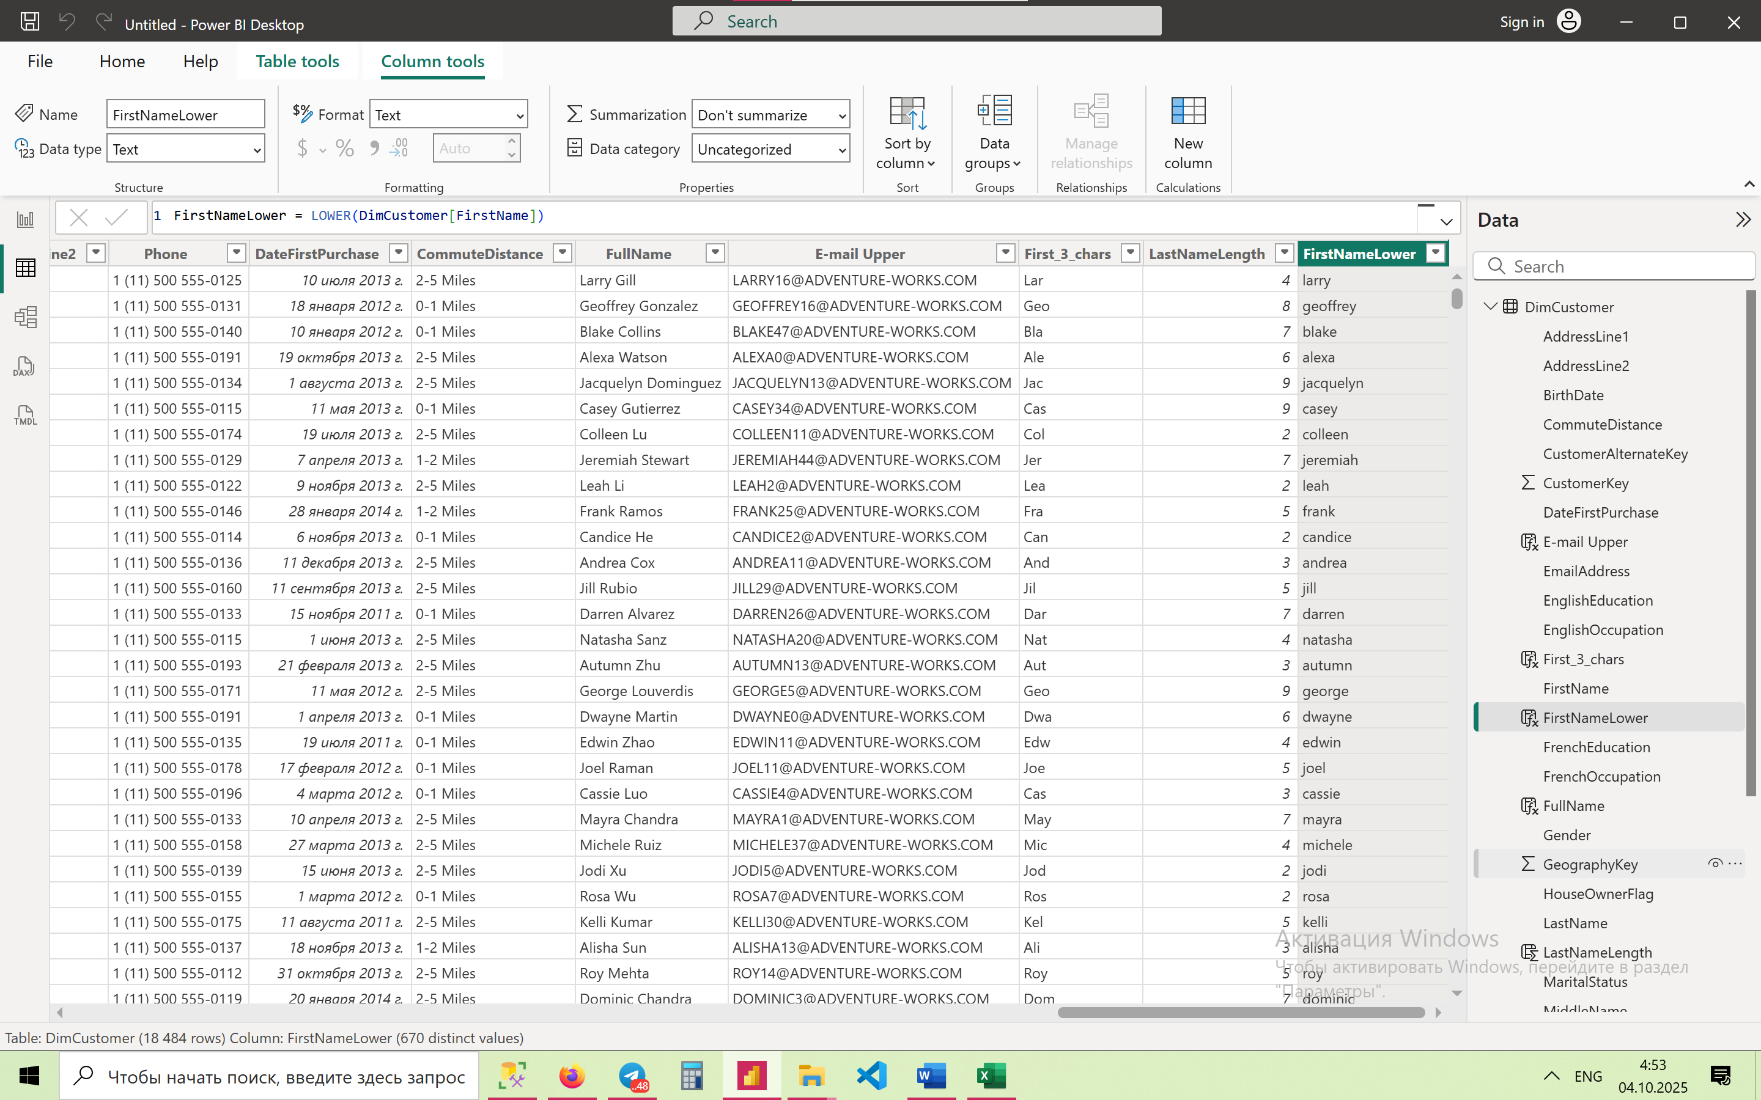

1. **Trim Spaces in EnglishEducation**

EducationTrimmed = TRIM(DimCustomer[EnglishEducation])

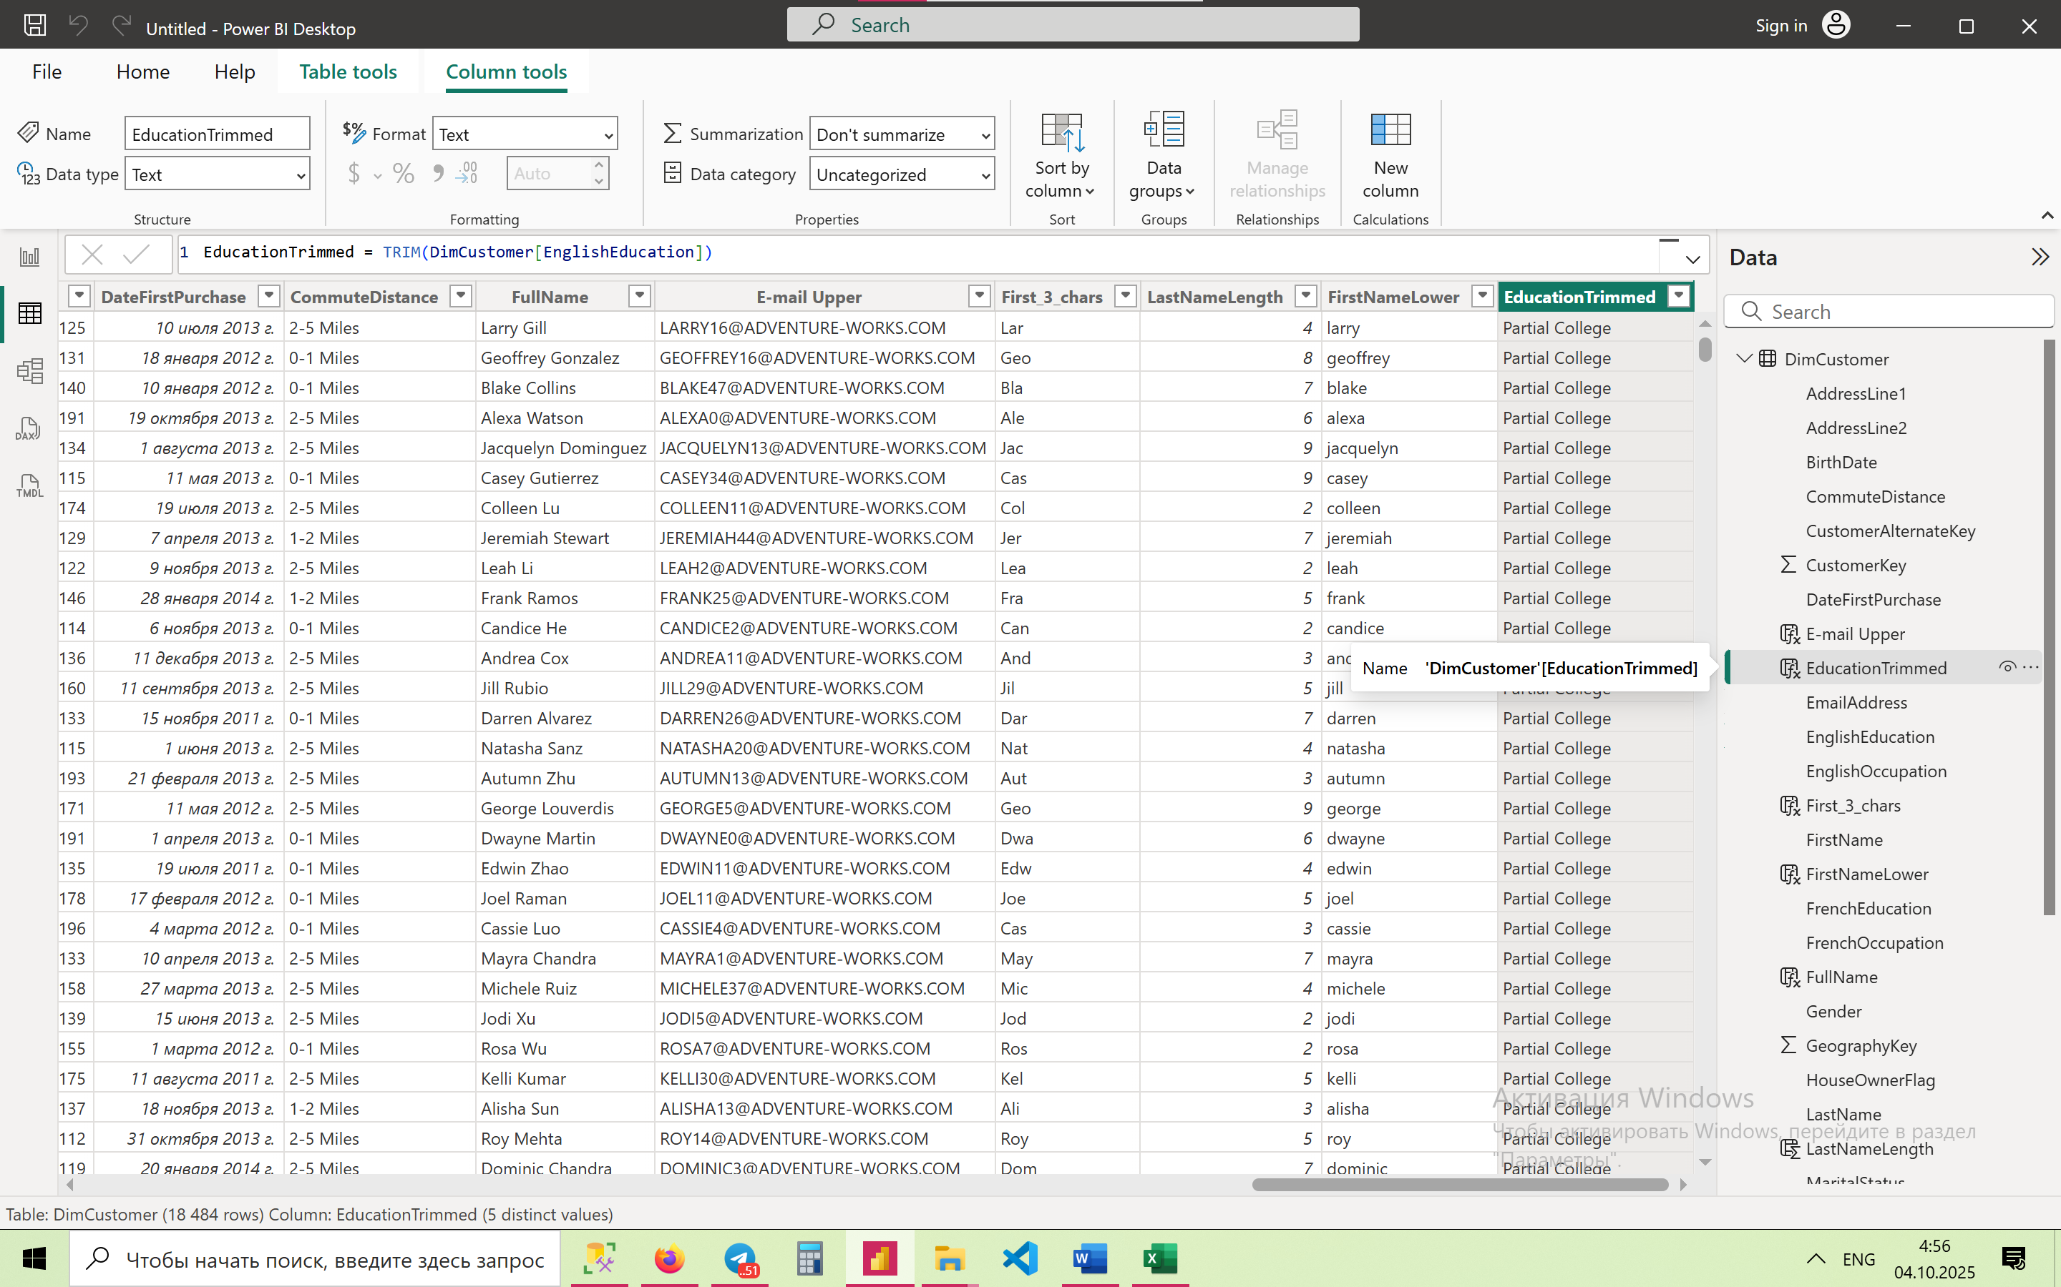

1. **Repeat '*' Character Equal to Length of First Name**

NameStars = REPT("*", LEN(DimCustomer[FirstName]))

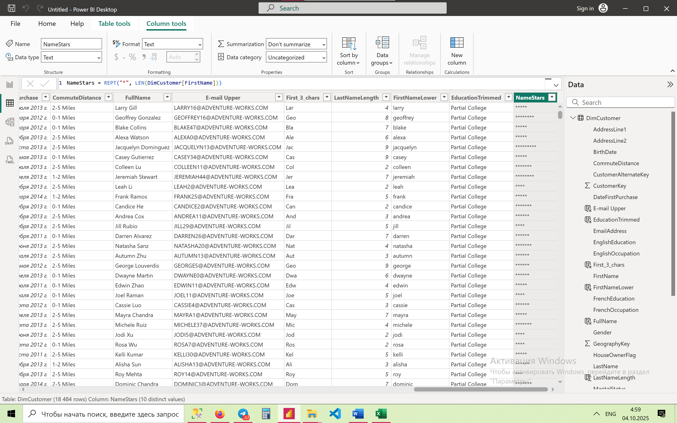

1. **Get Last 4 Characters of Phone Number**

Last4Phone = RIGHT(DimCustomer[Phone], 4)

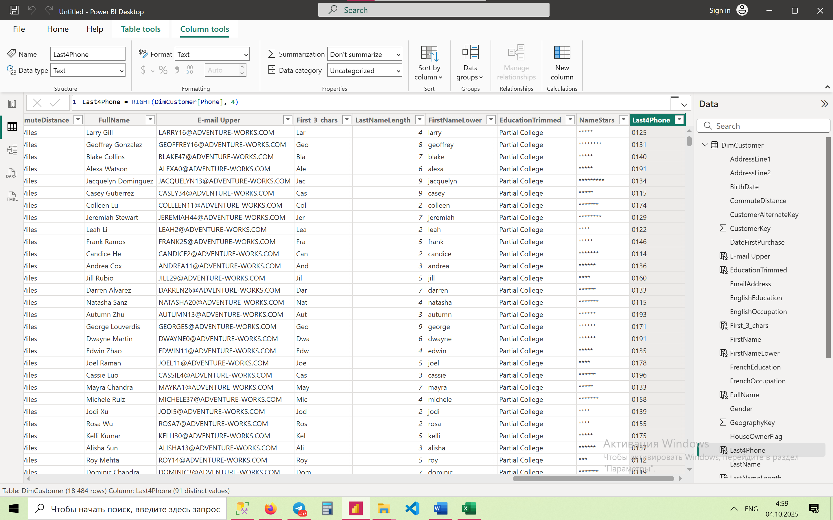

1. **Format YearlyIncome to Currency with 2 Decimals**

IncomeFormatted = FORMAT(DimCustomer[YearlyIncome], "$#,##0.00")

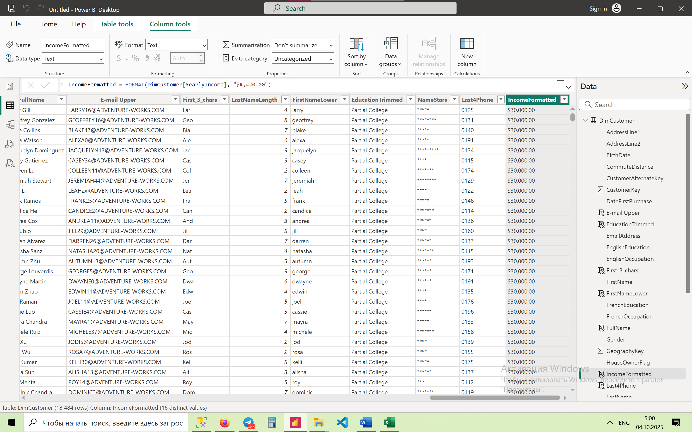

1. **Check If FirstName and LastName Are Exactly the Same**

SameName = IF(DimCustomer[FirstName] = DimCustomer[LastName], "Yes", "No")

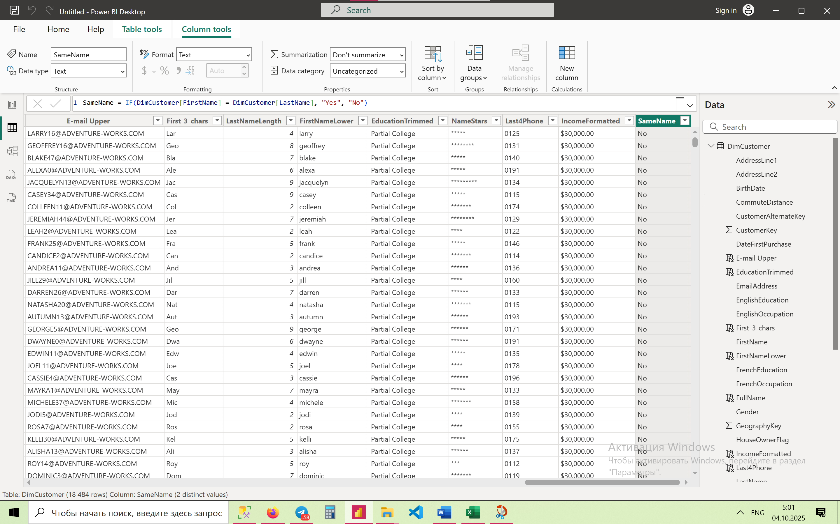

**🔹 Intermediate Level (11–20)**

1. **Find If 'Manager' Appears in Occupation (Case Sensitive)**

IsManager = IF(CONTAINSSTRING(DimCustomer[EnglishOccupation], "Manager"), "Yes", "No")

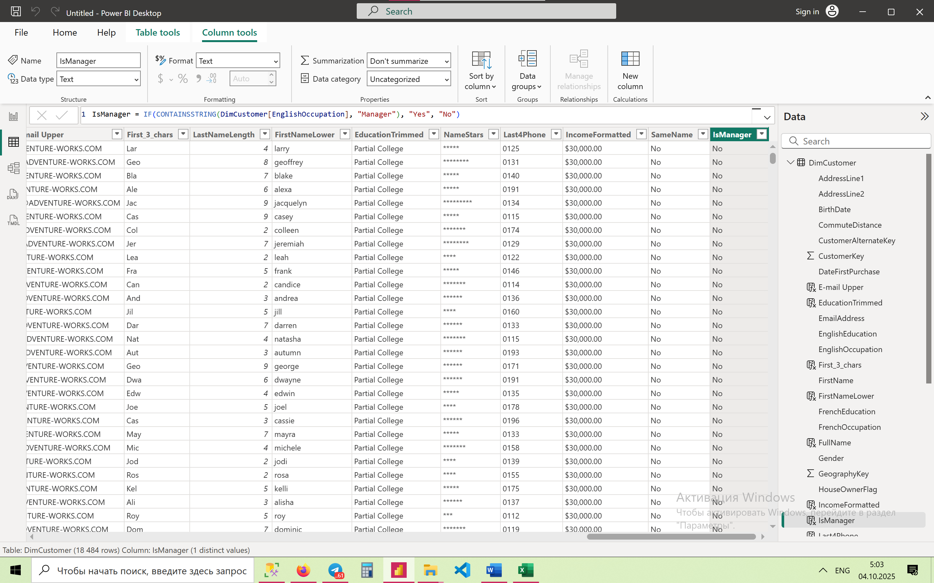

1. **Search for 'graduate' in EnglishEducation (Case Insensitive)**

ContainsGraduate = IF(CONTAINSSTRING(LOWER(DimCustomer[EnglishEducation]), "graduate"), "Yes", "No")

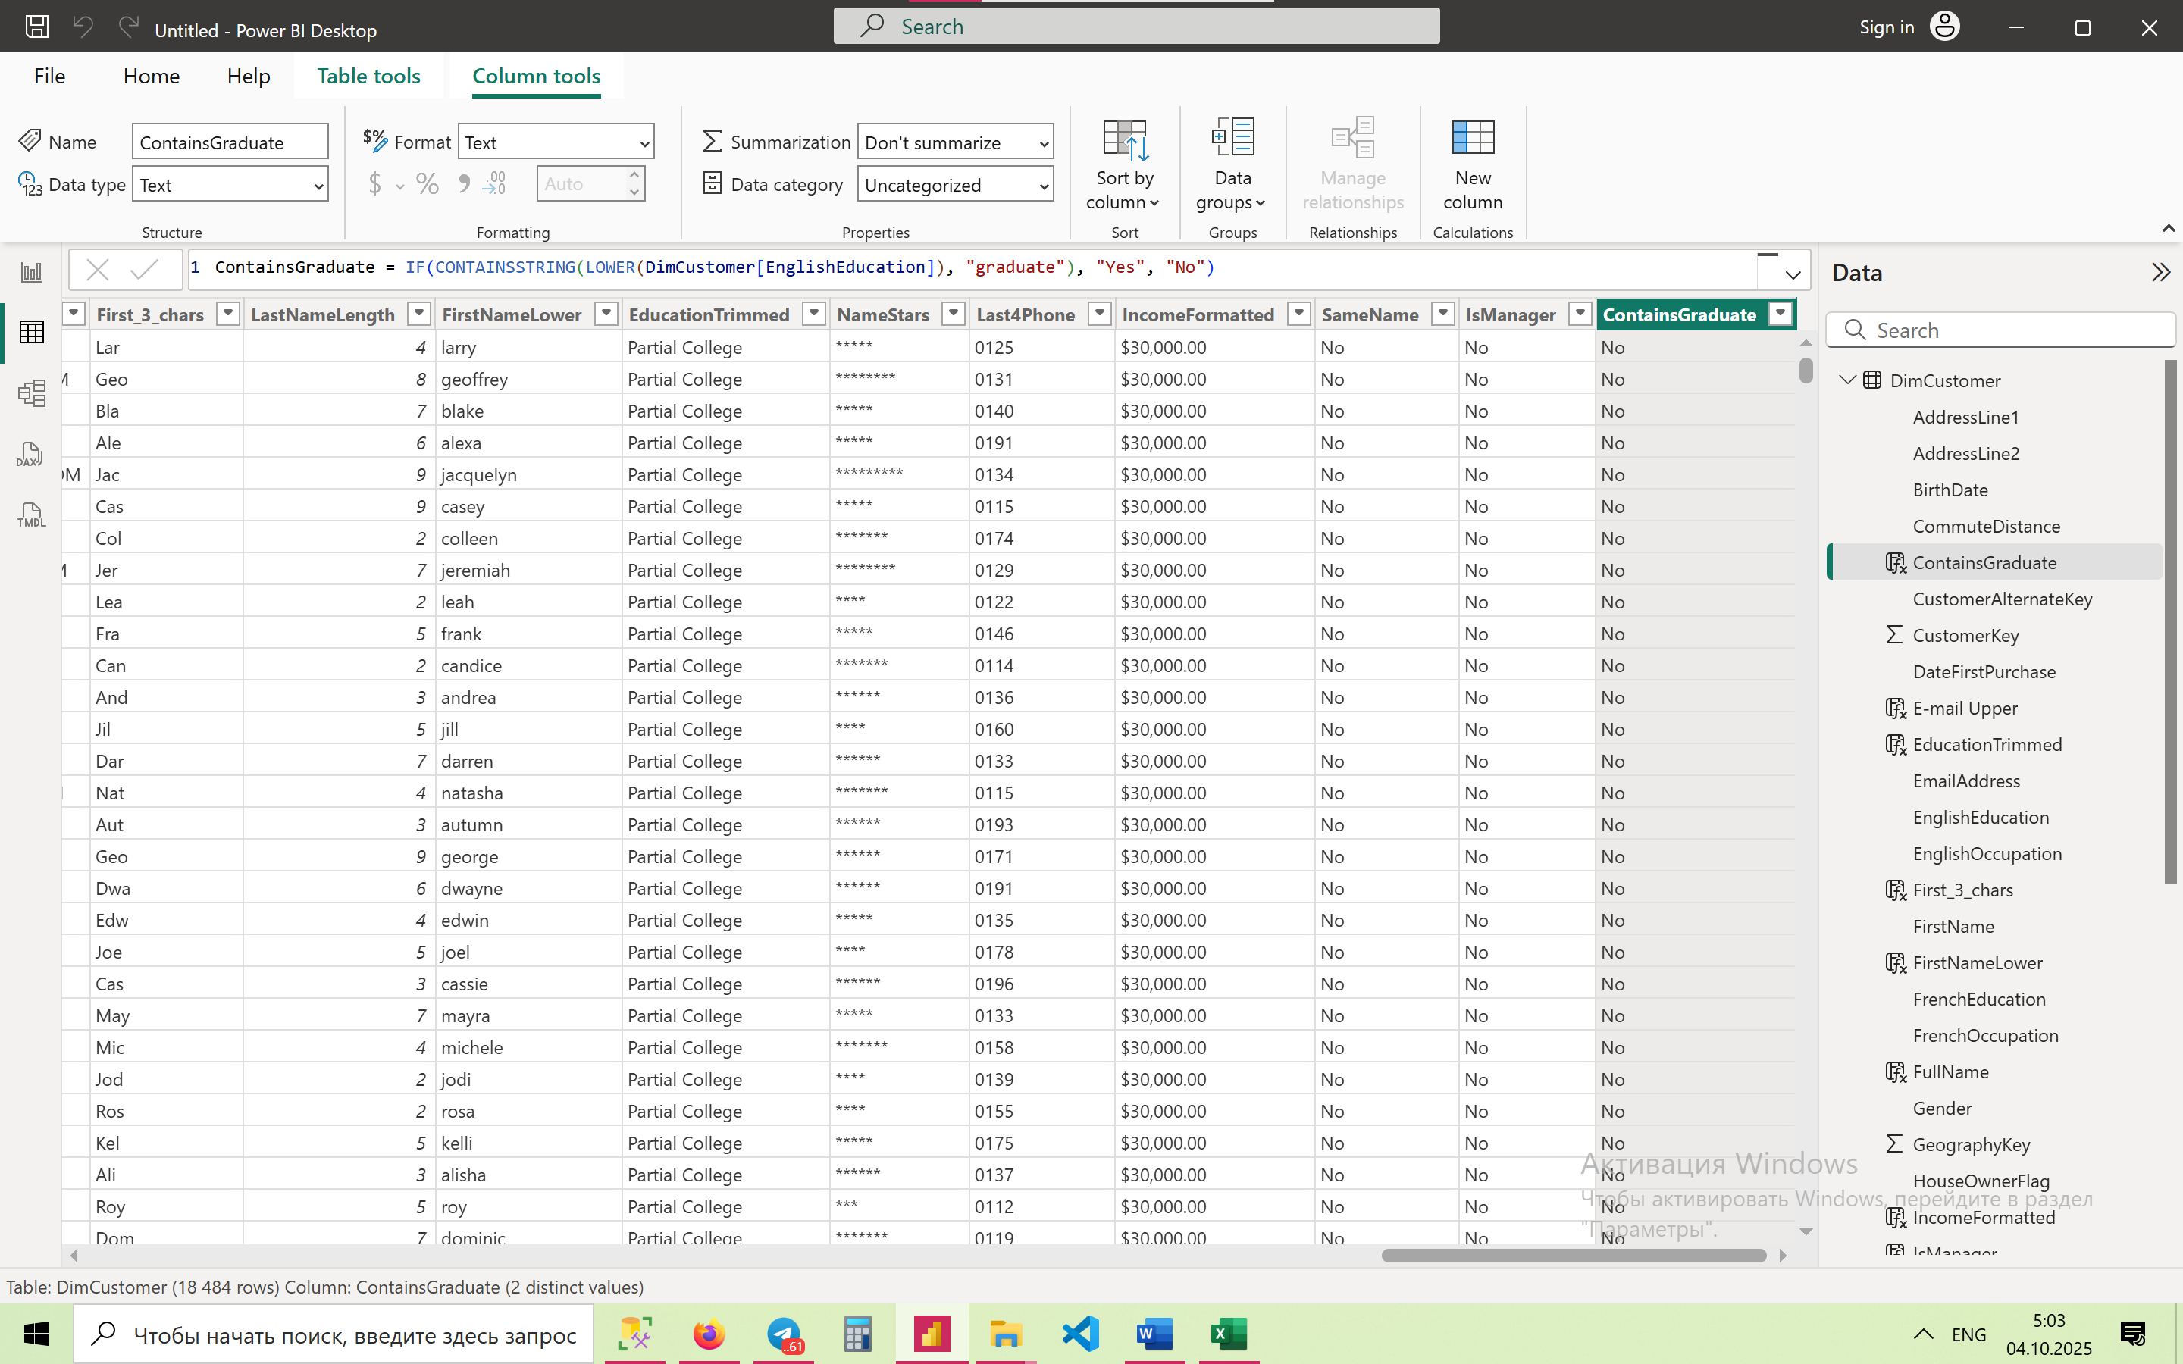

1. **Extract Characters 3–7 from First Name**

MidName = MID(DimCustomer[FirstName], 3, 5)

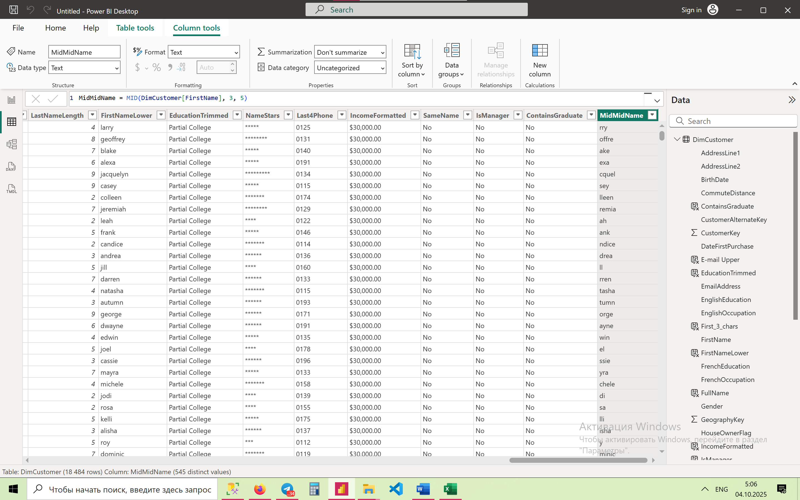

1. **Replace Area Code in Phone Number with 'XXX'**

PhoneMasked = "XXX" & RIGHT(DimCustomer[Phone], LEN(DimCustomer[Phone]) - 3)

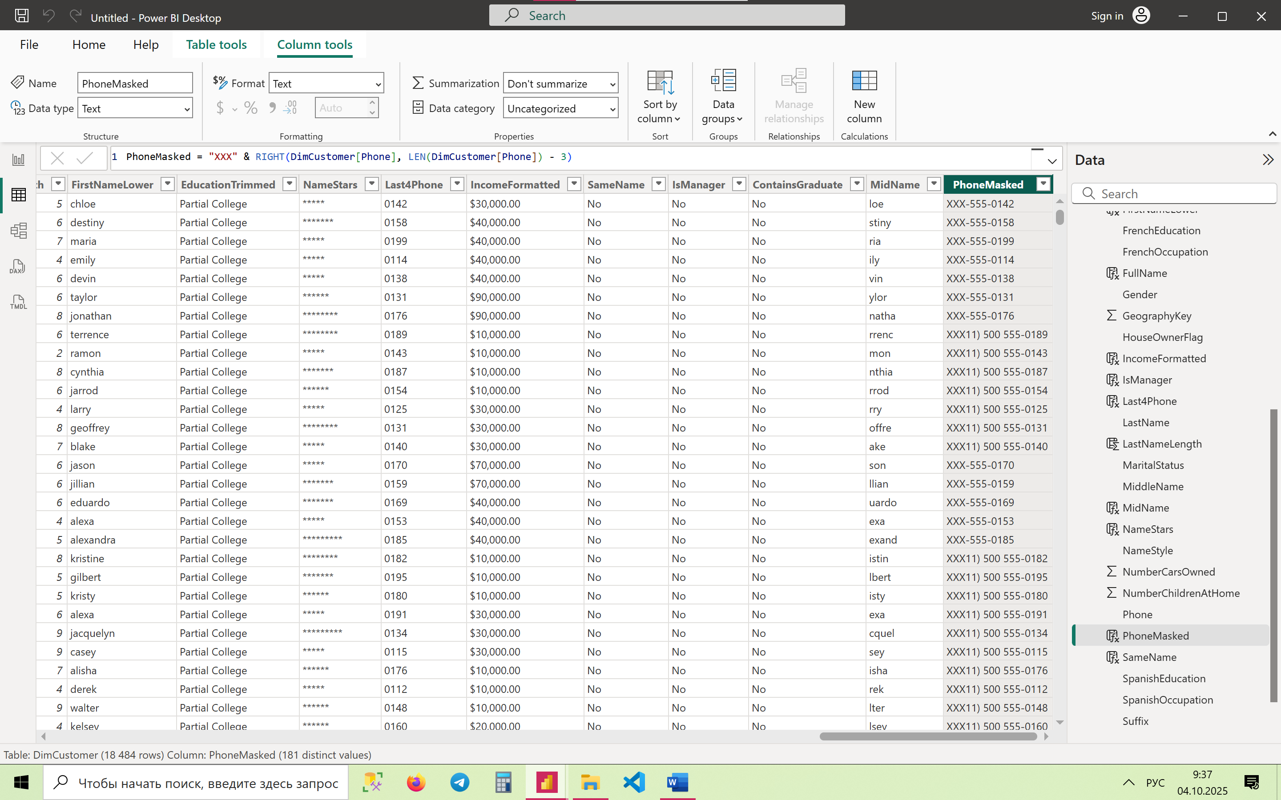

1. **Format BirthDate as 'DD-MM-YYYY'**

BirthDateFormatted = FORMAT(DimCustomer[BirthDate], "DD-MM-YYYY")

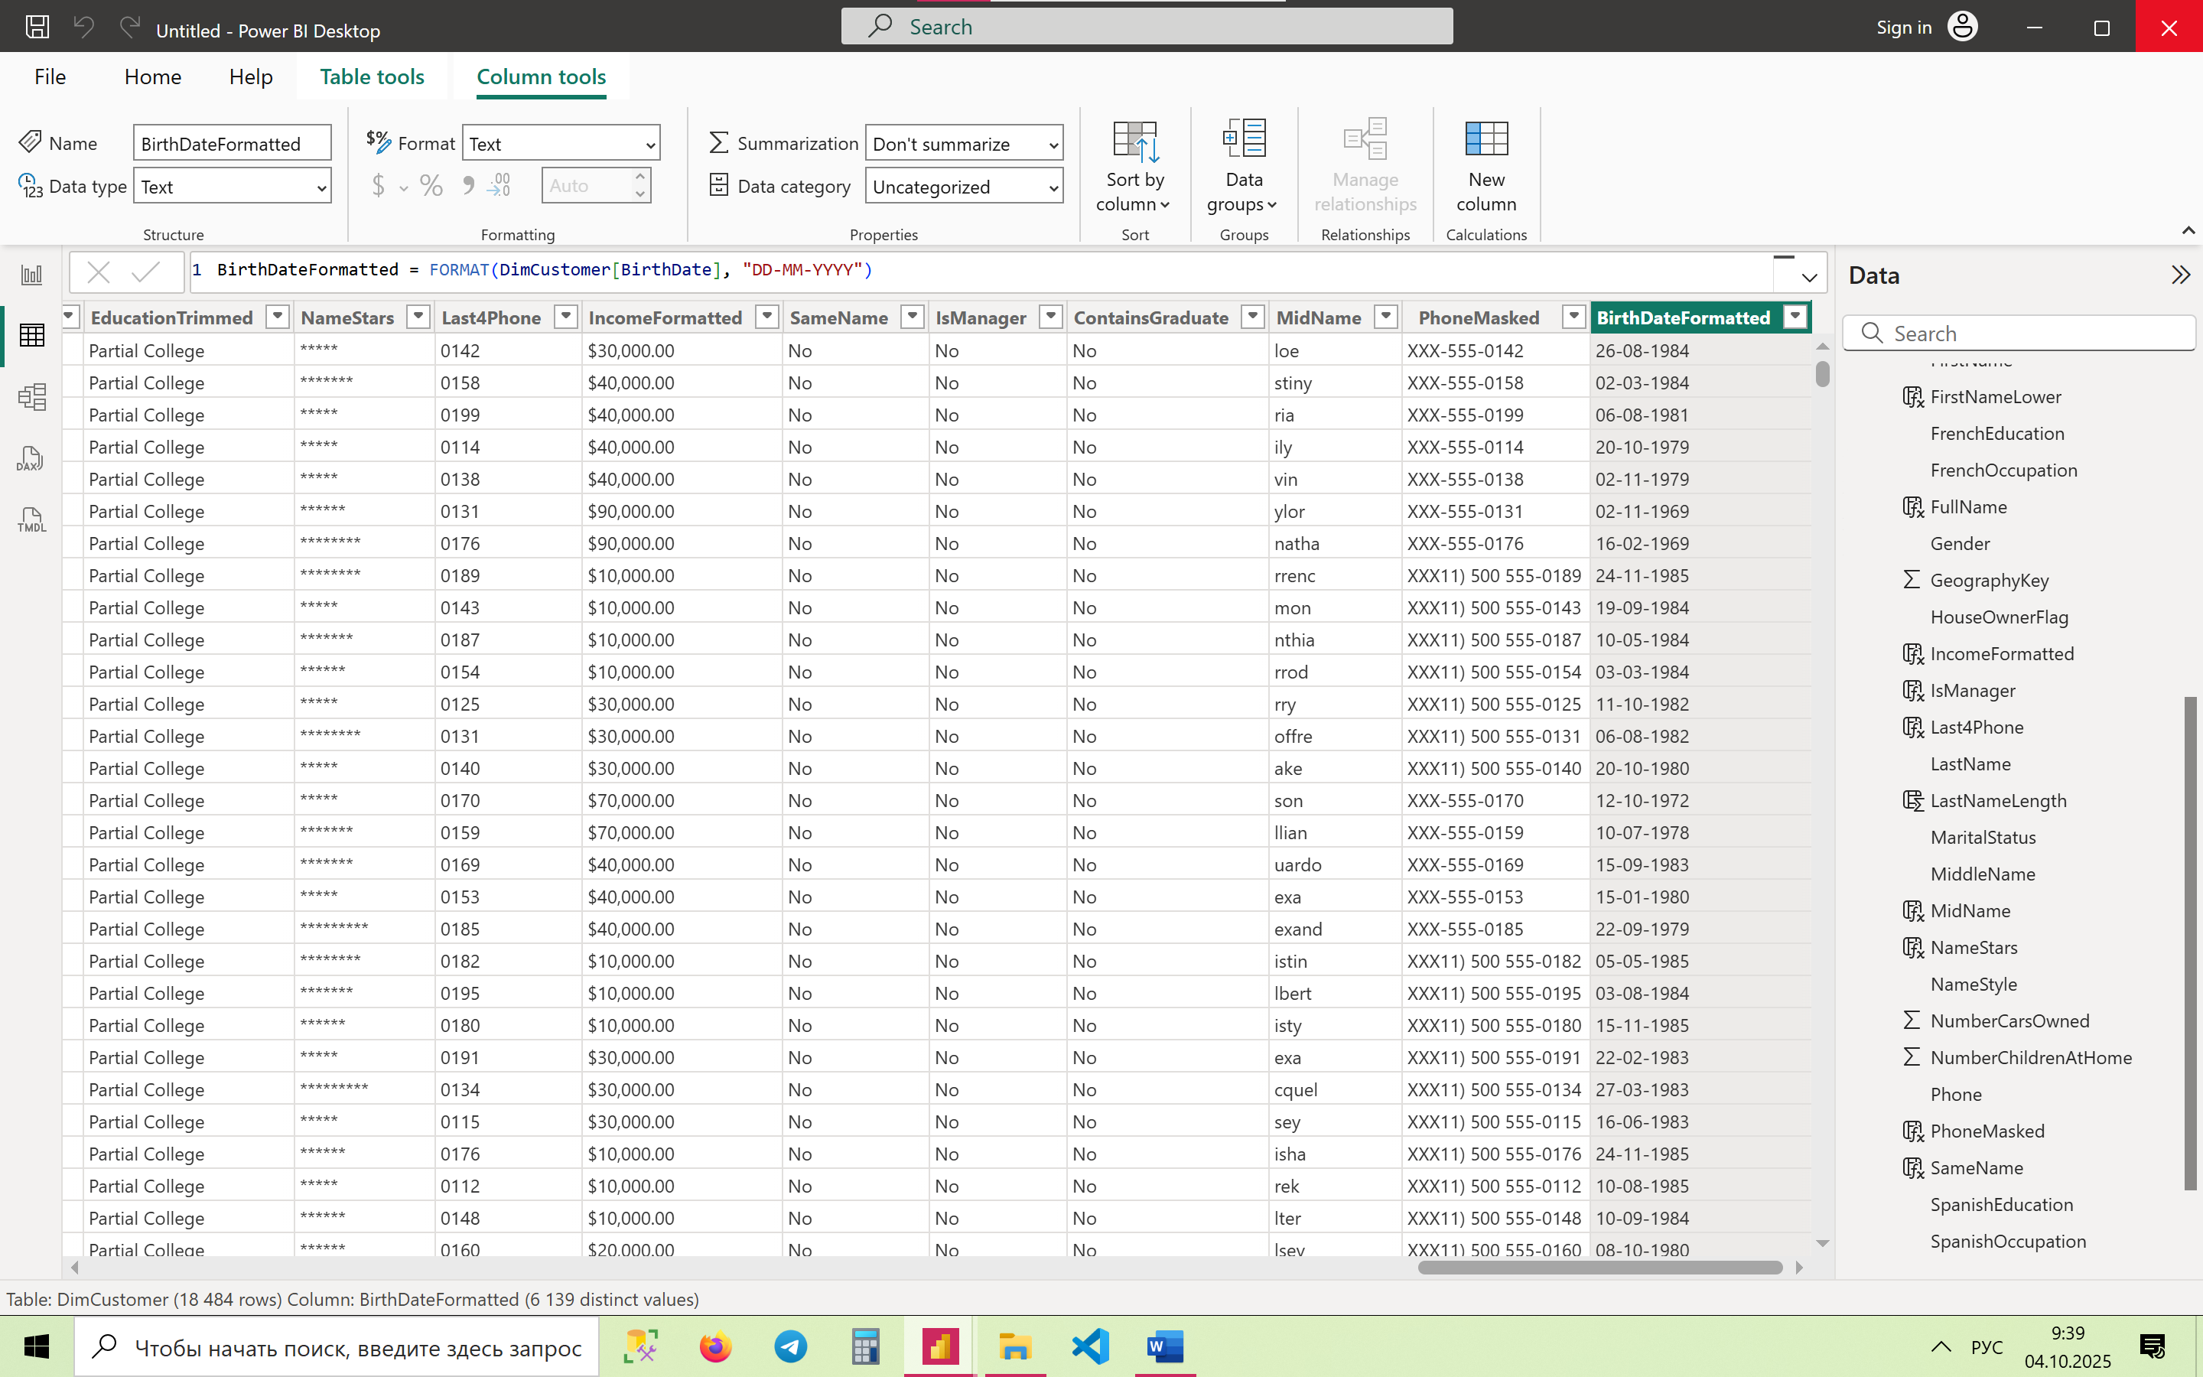

1. **Create Initial + Last Name Format (e.g. J.Smith)**

InitialLast = LEFT(DimCustomer[FirstName],1) & "." & DimCustomer[LastName]

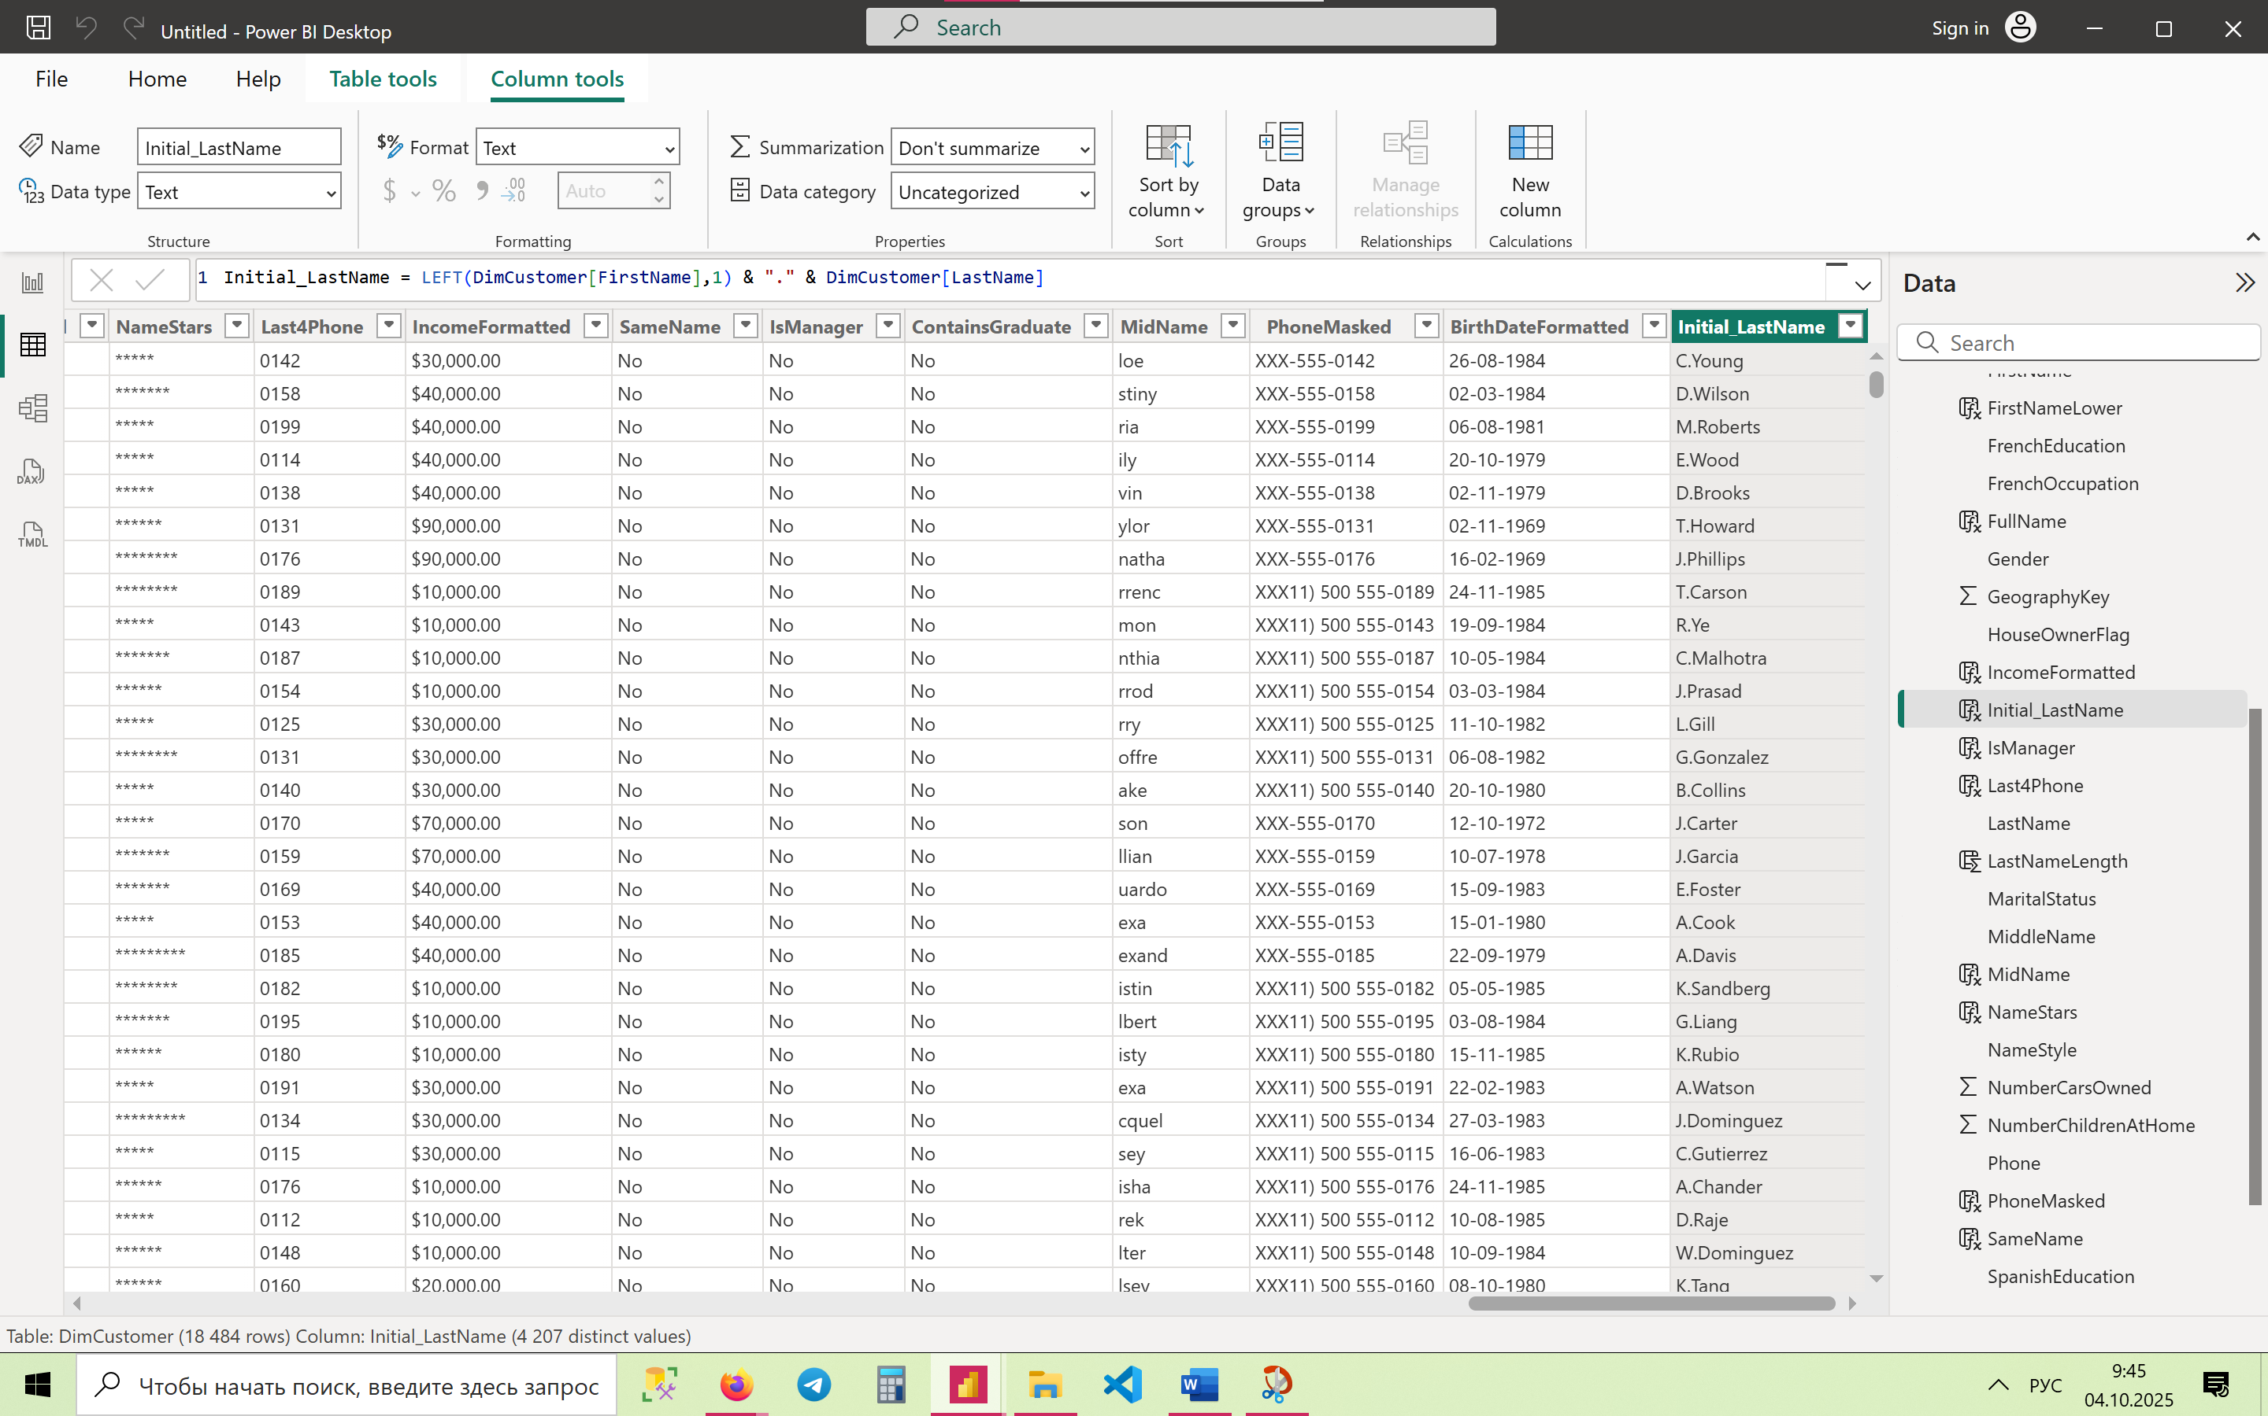

1. **Capitalize First Letter of FirstName, Lowercase the Rest**

FirstNameProper = UPPER(LEFT(DimCustomer[FirstName],1)) & LOWER(MID(DimCustomer[FirstName],2,LEN(DimCustomer[FirstName])-1))

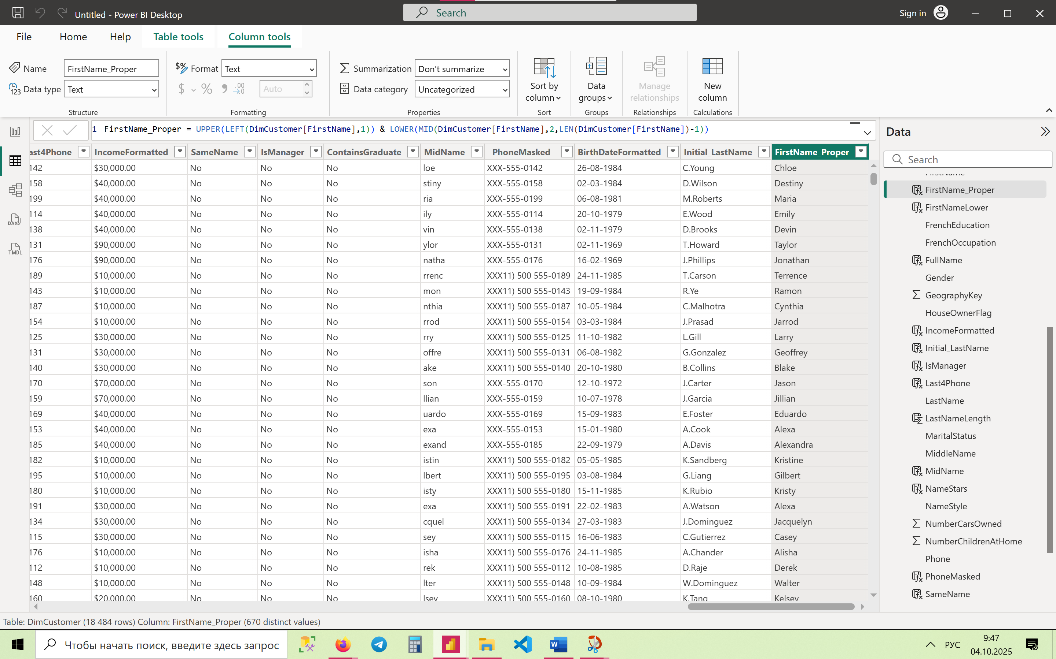

1. **Substitute Dashes with Spaces in Phone**

PhoneNoDash = SUBSTITUTE(DimCustomer[Phone], "-", " ")

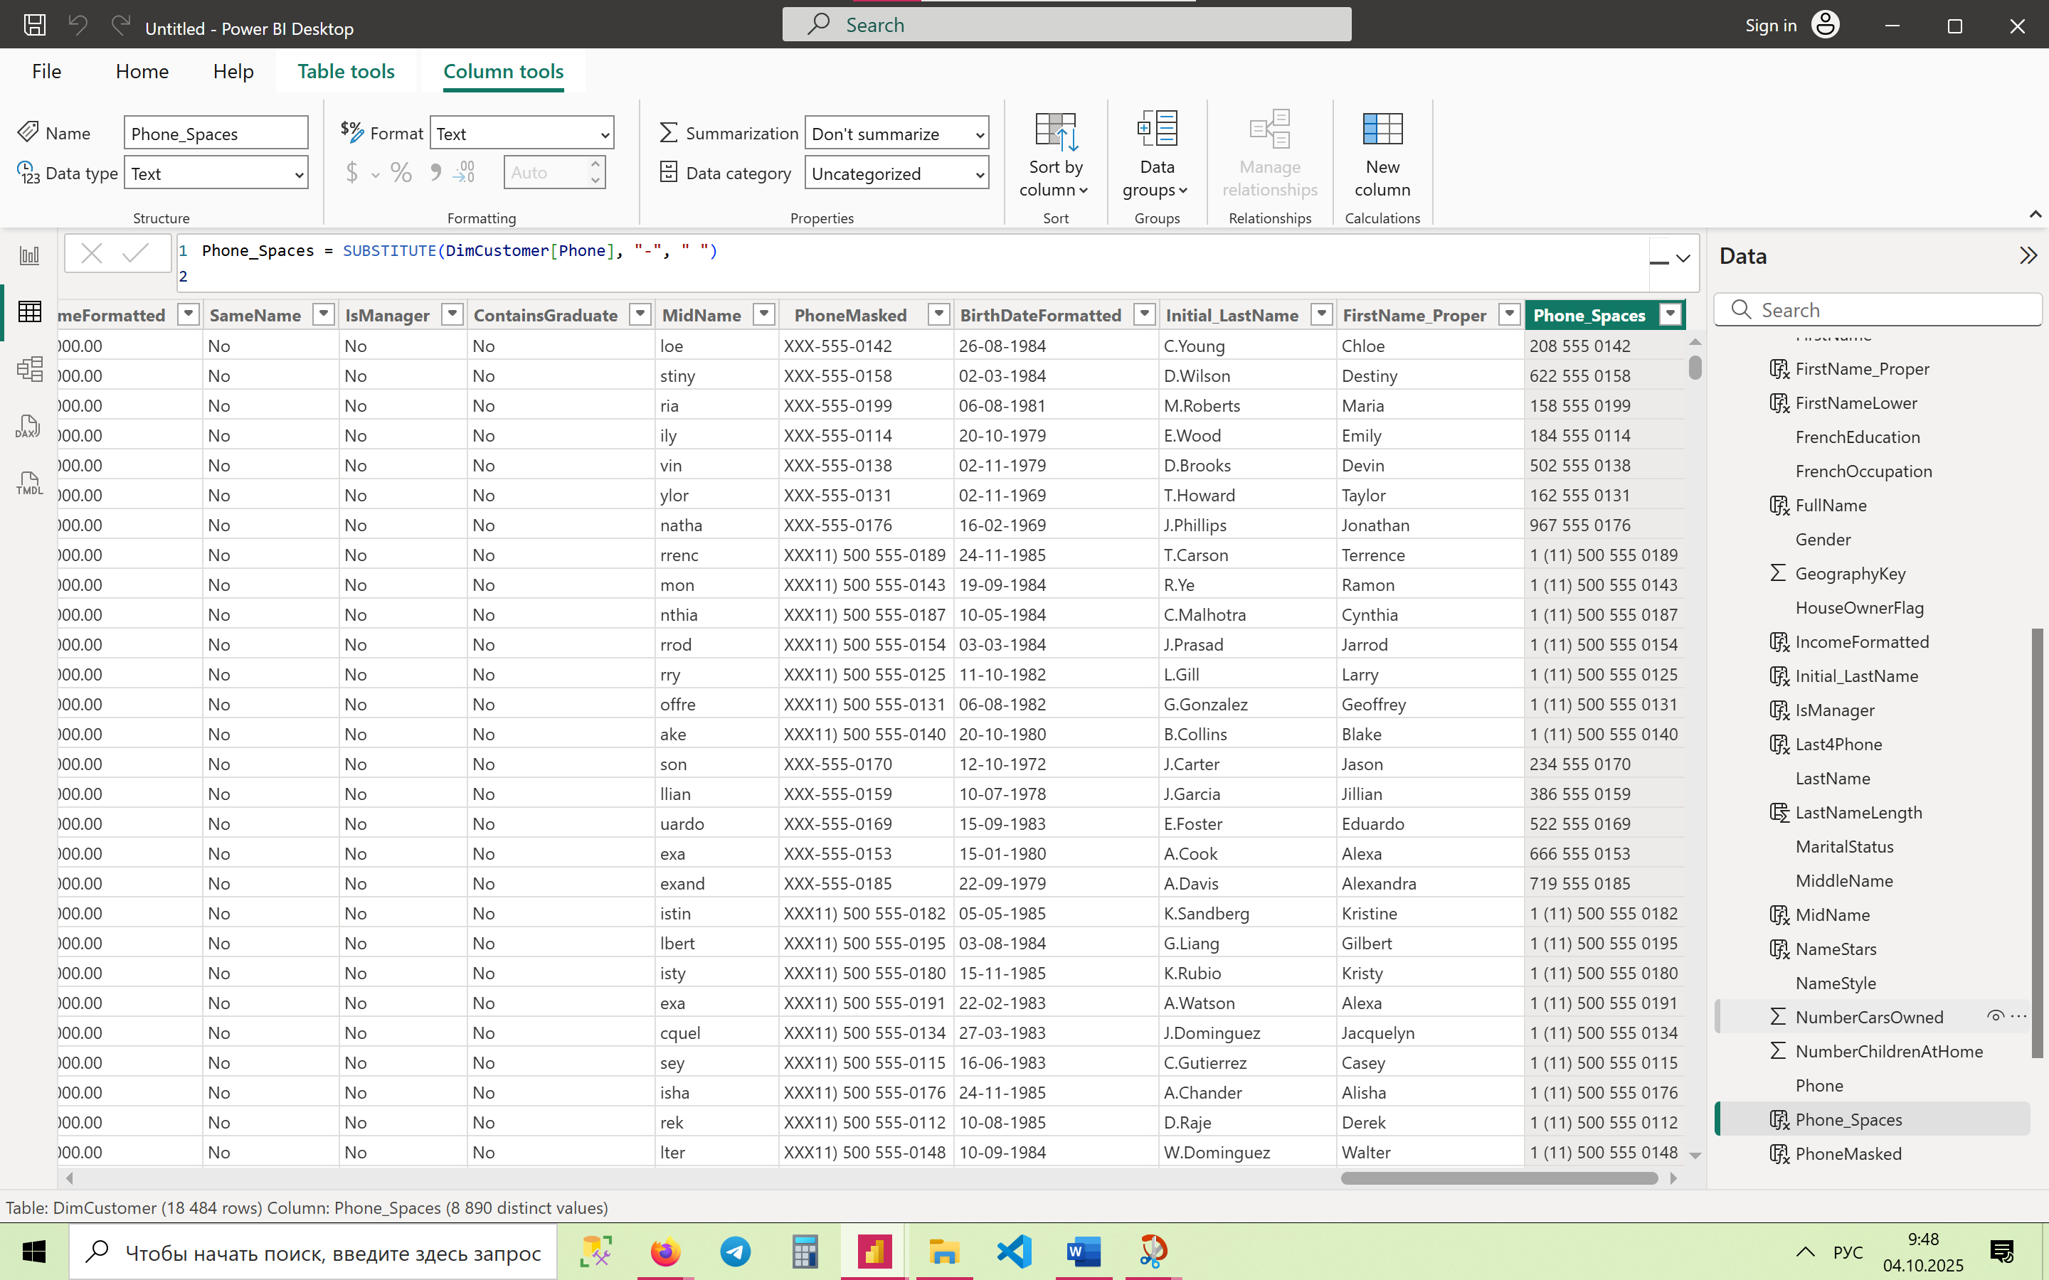

1. **Convert BirthDate Year to Numeric Using VALUE**

BirthYear = VALUE(FORMAT(DimCustomer[BirthDate], "YYYY"))

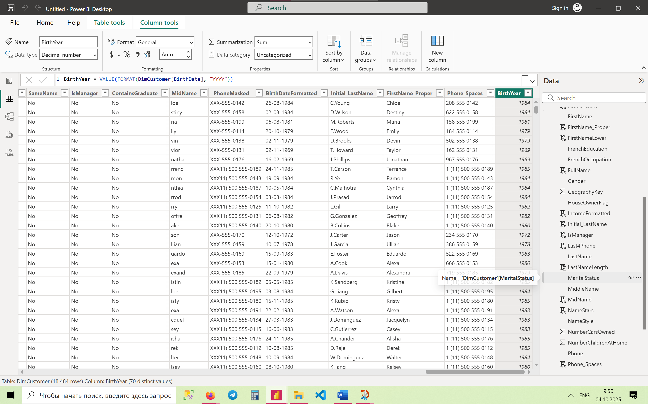

1. **Show YearlyIncome Rounded to 1 Decimal Without Commas**

IncomeRounded = FORMAT(ROUND(DimCustomer[YearlyIncome],1), "0.0")

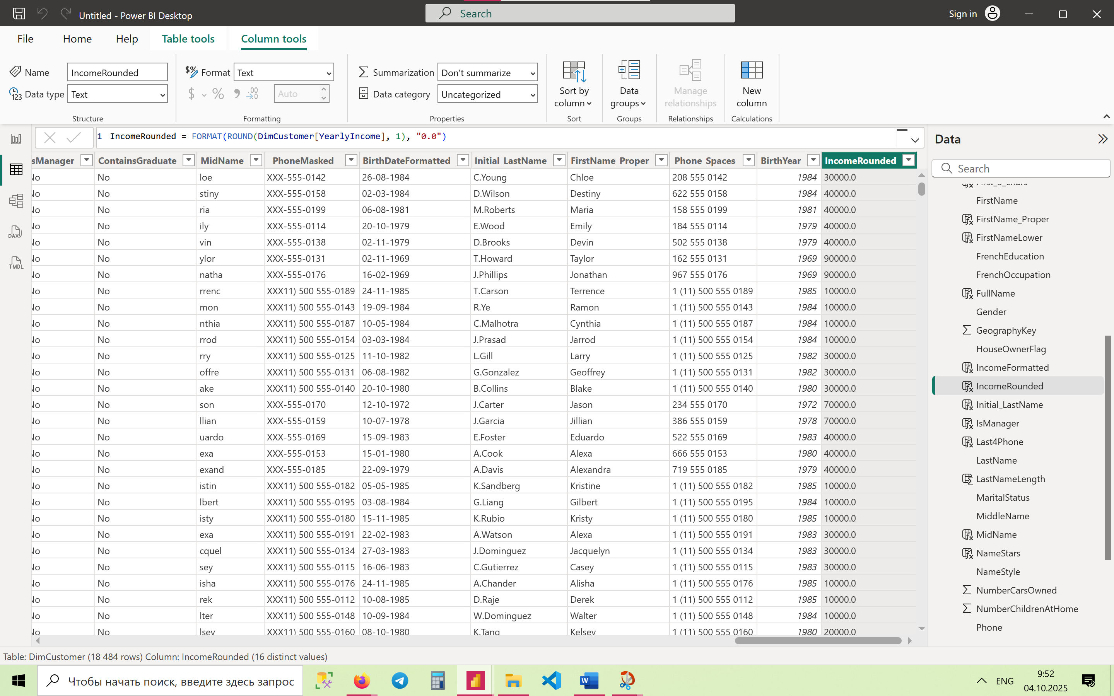

**🔹 Advanced Level (21–30)**

1. **Customer Code: First 2 Letters of LastName + Last 2 of CustomerKey**

CustomerCode = LEFT(DimCustomer[LastName],2) & RIGHT(DimCustomer[CustomerKey],2)

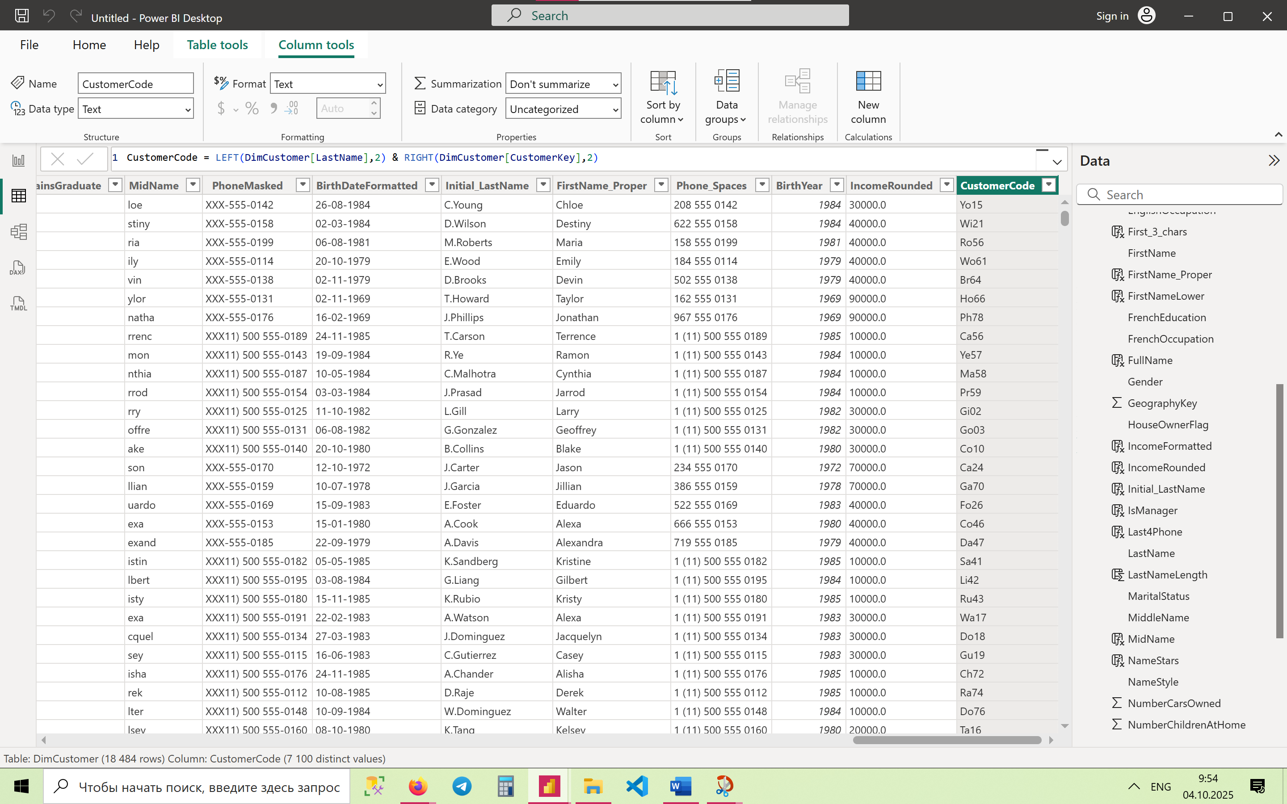

1. **Validate Email Ends with '.com' and Contains '@'**

ValidEmail = IF(

CONTAINSSTRING(DimCustomer[EmailAddress], "@") &&

RIGHT(DimCustomer[EmailAddress],4) = ".com",

"Valid","Invalid"

)

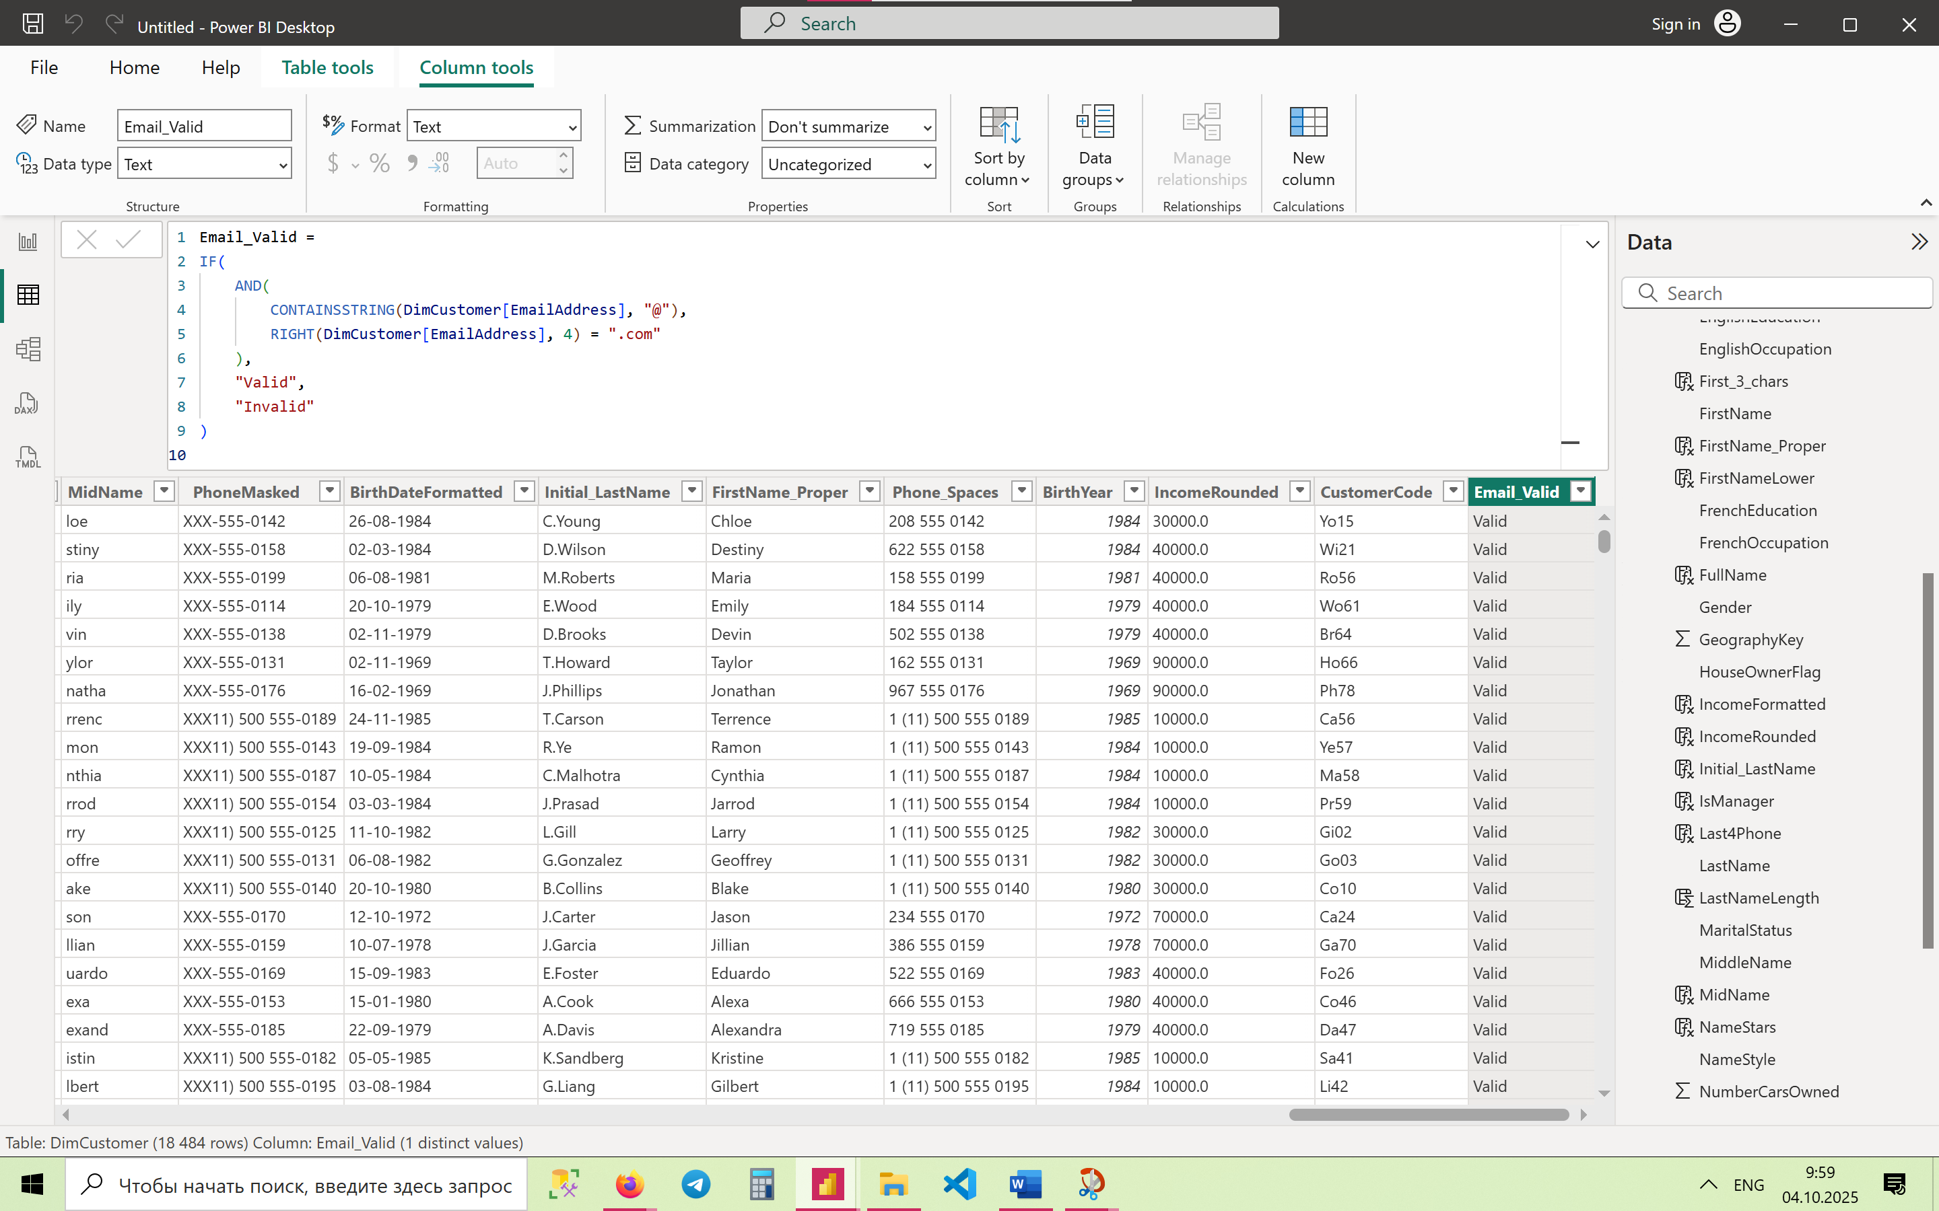

1. **Extract Domain Name from EmailAddress**

EmailDomain = RIGHT(DimCustomer[EmailAddress], LEN(DimCustomer[EmailAddress]) - FIND("@", DimCustomer[EmailAddress]))

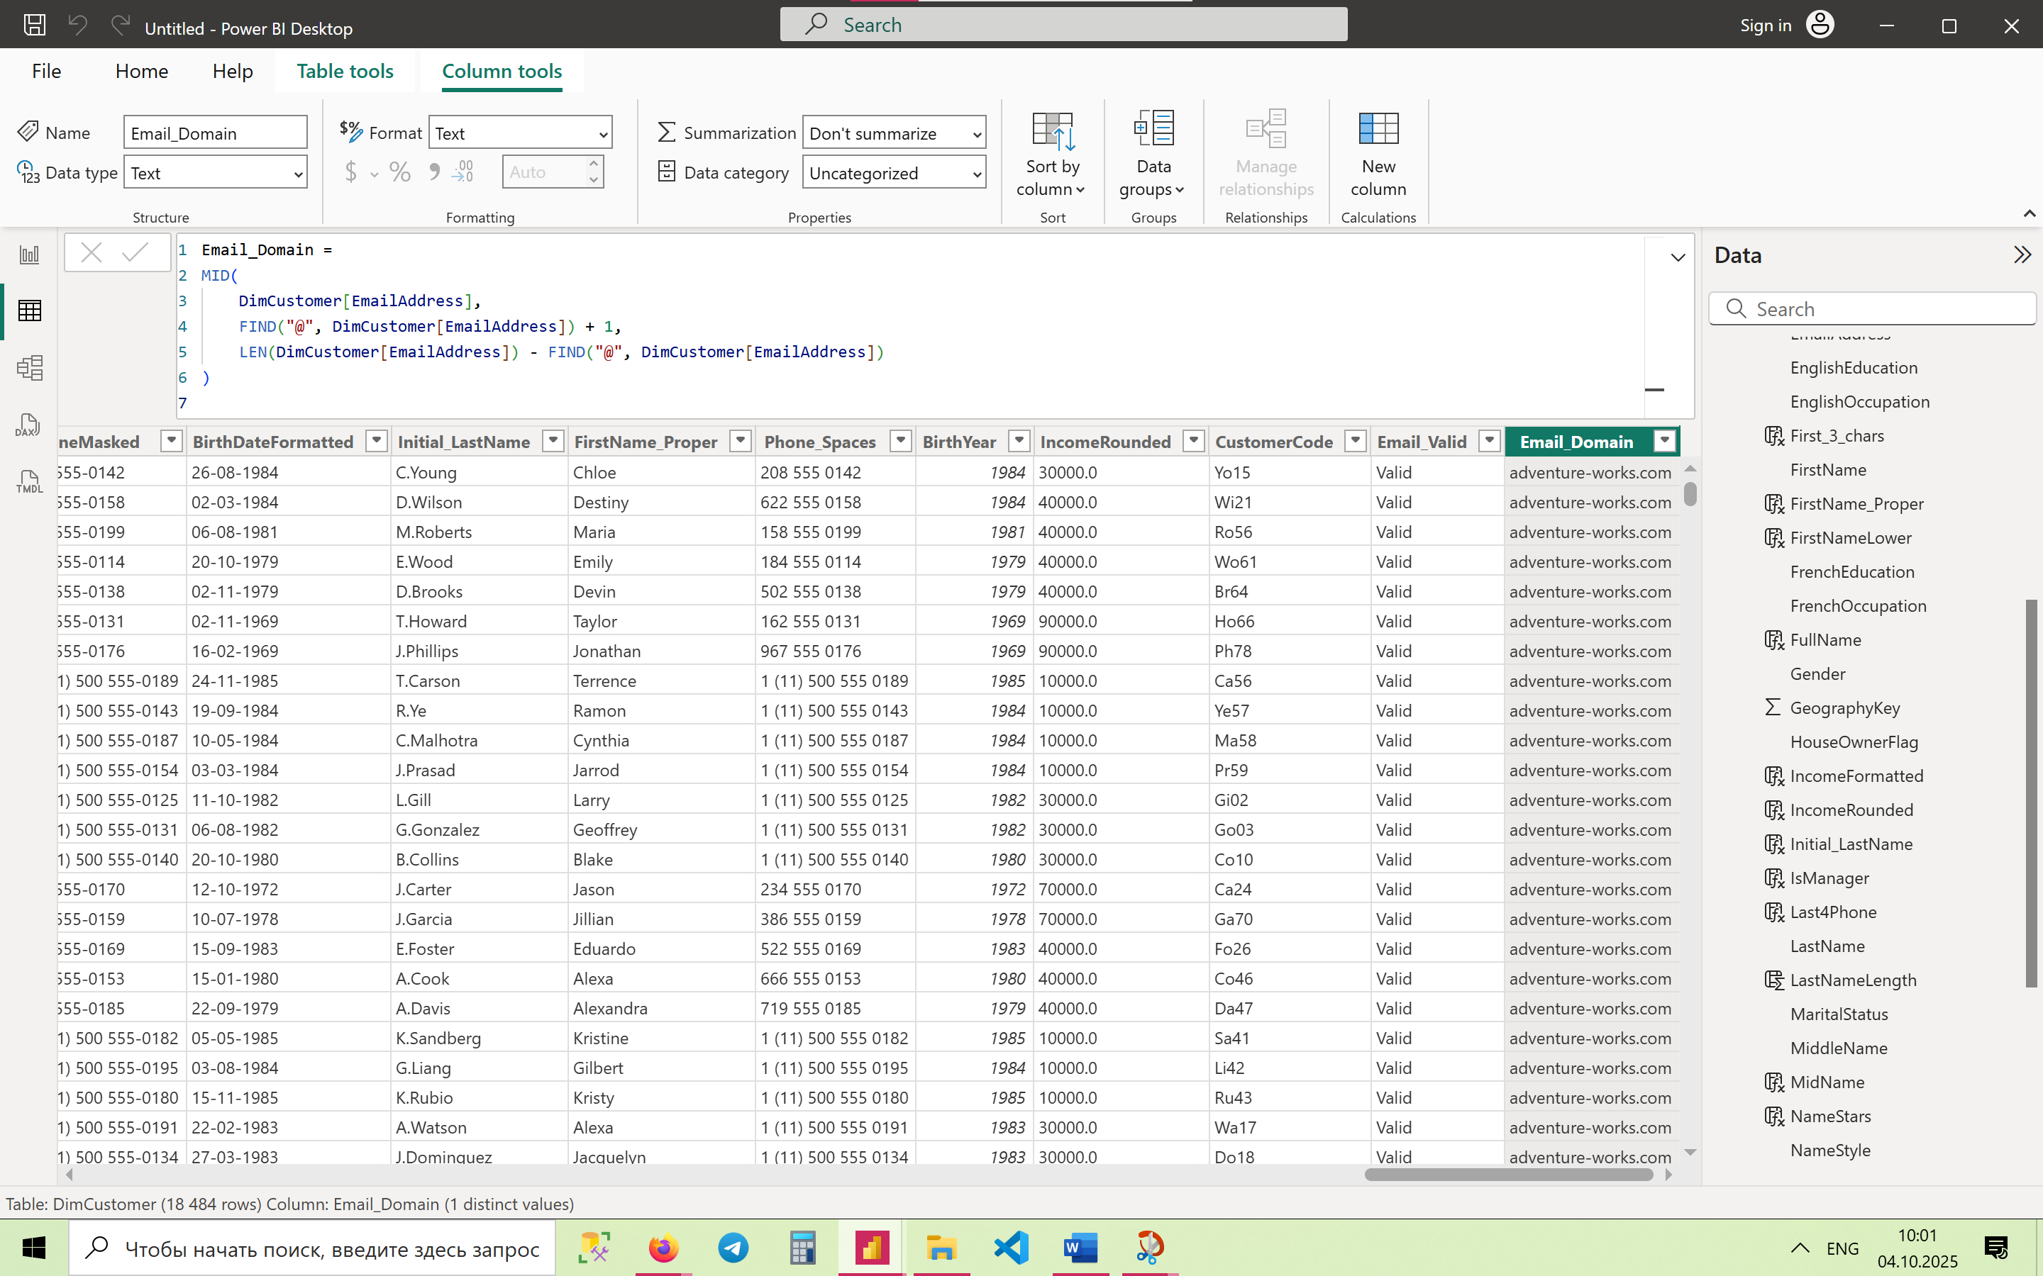

1. **Mask Phone Number Except Last 4 Digits**

PhoneMasked = REPT("X", LEN(DimCustomer[Phone])-4) & RIGHT(DimCustomer[Phone],4)

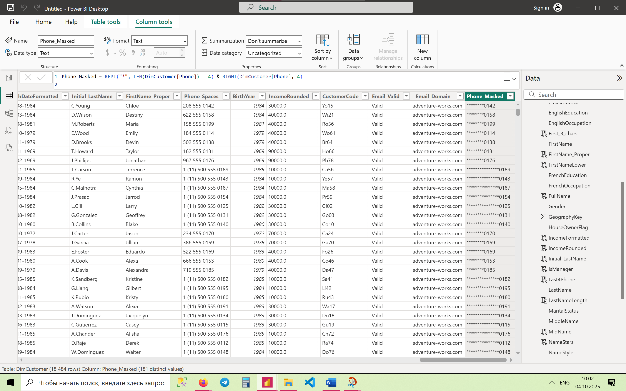

1. **Proper Casing of Last Name (simulate manually)**

LastNameProper = UPPER(LEFT(DimCustomer[LastName],1)) & LOWER(MID(DimCustomer[LastName],2,LEN(DimCustomer[LastName])-1))

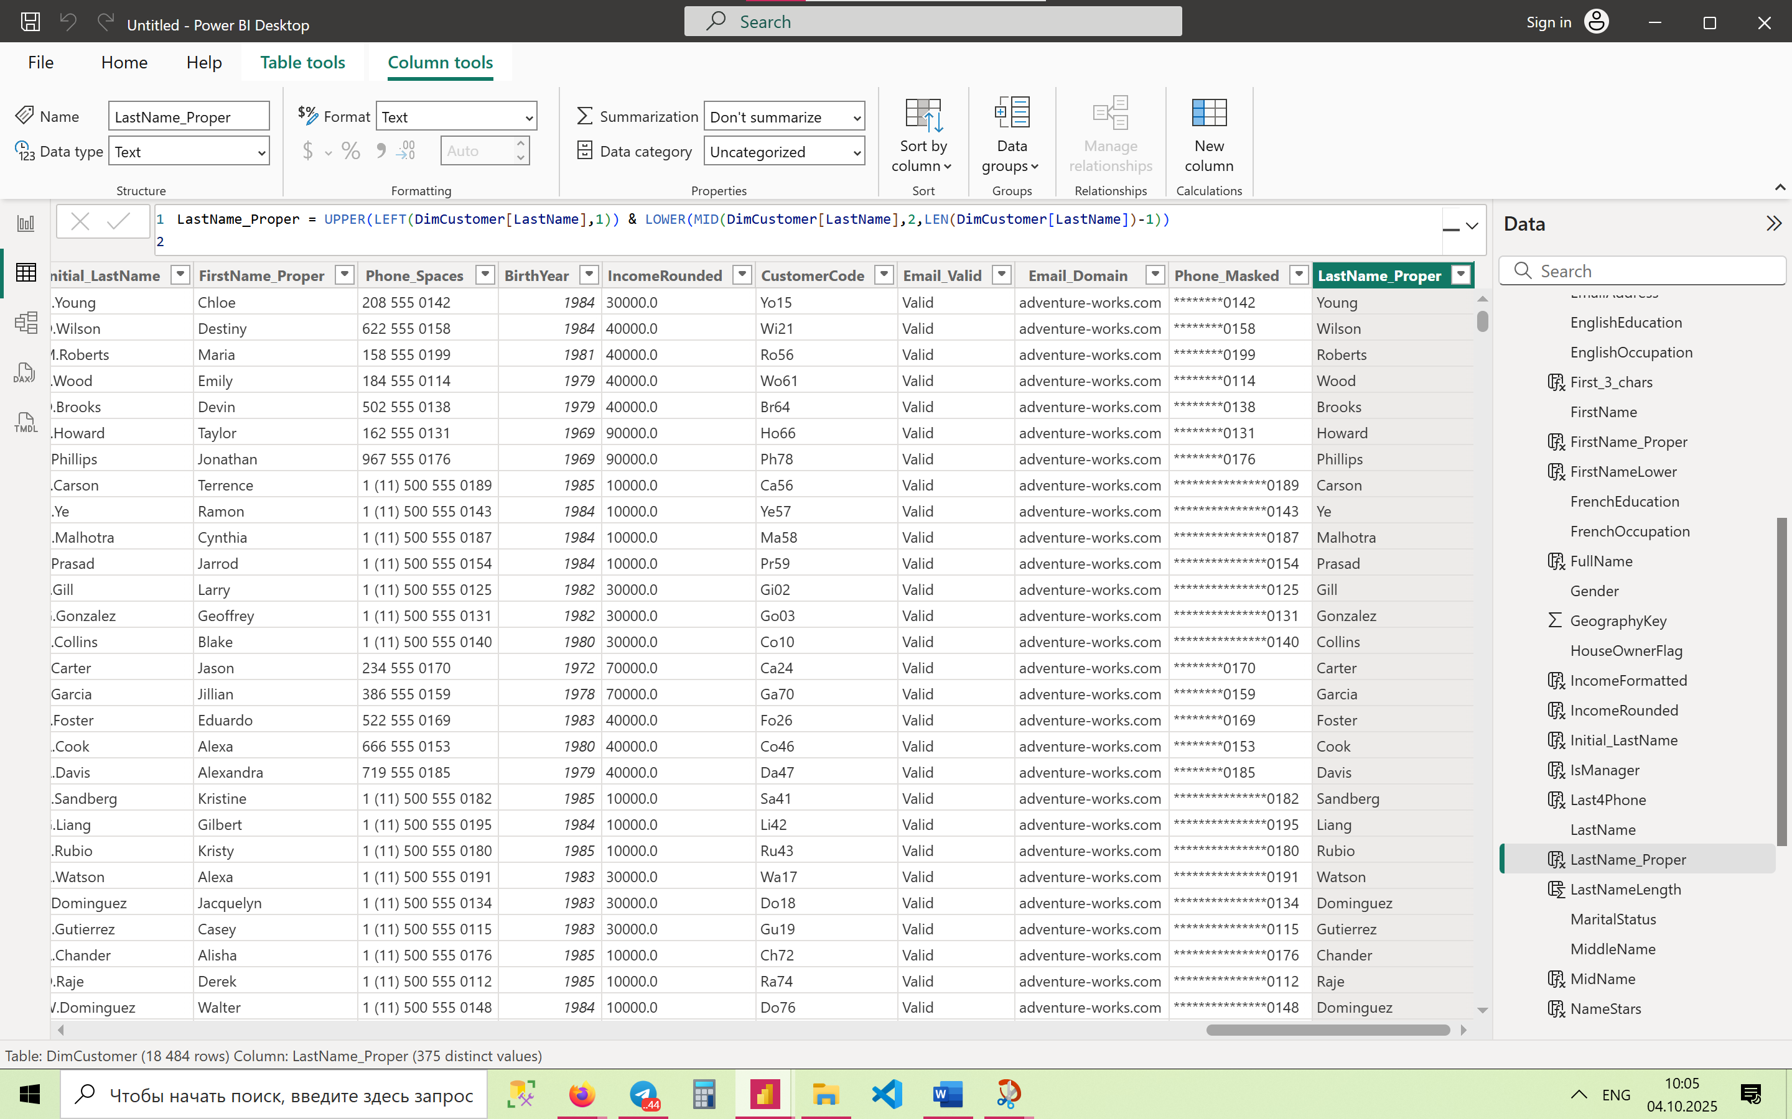

1. **Replace Multiple Spaces in EnglishOccupation with Single Space**

OccupationClean = SUBSTITUTE(SUBSTITUTE(DimCustomer[EnglishOccupation], " ", " "), " ", " ")

1. **Generate Custom ID: Initials + Birth Year (e.g., JD_1985)**

CustomID = LEFT(DimCustomer[FirstName],1) & LEFT(DimCustomer[LastName],1) & "_" & FORMAT(DimCustomer[BirthDate],"YYYY")

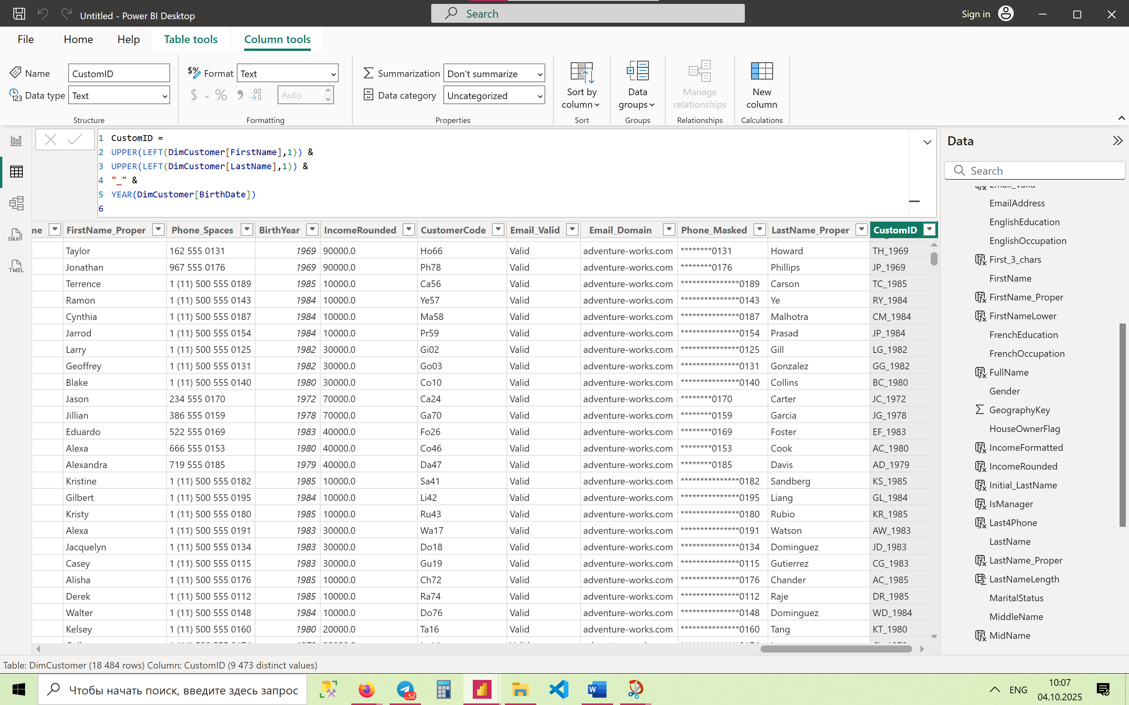

1. **Remove Hyphens and Convert Phone to Number**

PhoneNumeric = VALUE(SUBSTITUTE(DimCustomer[Phone], "-", ""))

1. **Customer Segmentation (Education + Income)**

CustomerSegment =

SWITCH(

TRUE(),

DimCustomer[EnglishEducation] = "Graduate Degree" && DimCustomer[YearlyIncome] > 90000, "Elite",

DimCustomer[EnglishEducation] = "Bachelors" && DimCustomer[YearlyIncome] >= 60000 && DimCustomer[YearlyIncome] <= 90000, "Professional",

DimCustomer[EnglishEducation] = "High School", "Basic",

"Other"

)

1. **Dynamic Customer Count by Gender (with conditions)**

CustomerCountByGender =

VAR GenderCount = DISTINCTCOUNT(DimCustomer[Gender])

RETURN

IF(

ISFILTERED(DimCustomer[Gender]),

IF(GenderCount=1, COUNTROWS(VALUES(DimCustomer[CustomerKey])), "Multiple Values Selected"),

COUNTROWS(DimCustomer)

)